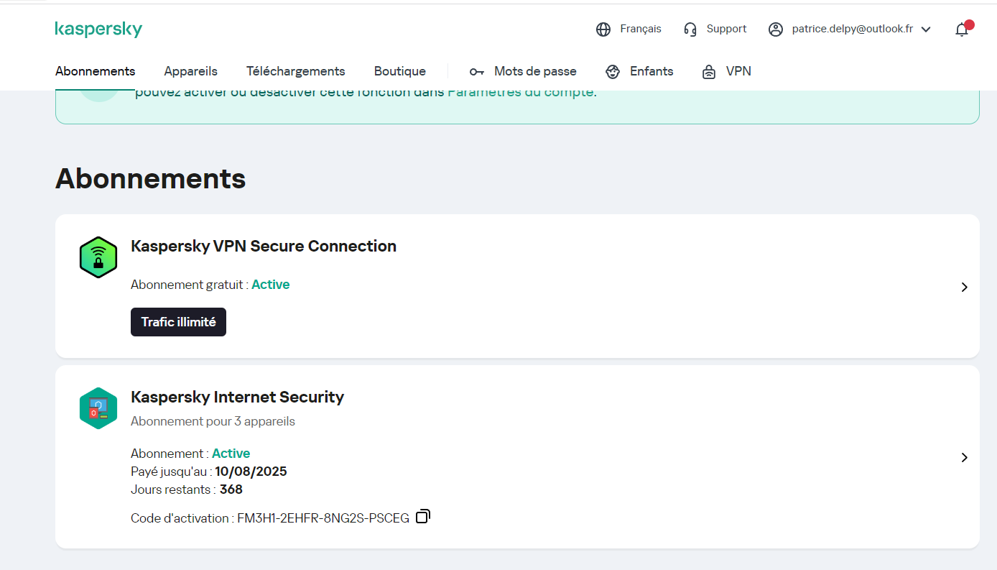
FM3H1-2EHFR-8NG2S-PSCEG
https://my.kaspersky.com/MyLicenses#/portal/pages/licenses/all

clé de la licence
2443211F-38C4-40E1-96C4-1432B71F570D

