Suivi des expéditions
On parle aussi de shipping tracking
https://tutoriels.lws.fr/woocommerce/proposer-le-suivi-des-expeditions-dans-woocommerce
gérer les livraisons avec woocommerce
Woocommerce advanced shipping –JEM plugins)
Advanced shipment tracking for woocommerce (zorem) AST
https://wordpress.org/plugins/colissimo-shipping-methods-for-woocommerce/

https://techsbucket.com/advanced-shipment-tracking-pro-31/
https://nullphpscript.com/post/advanced-shipment-tracking-pro-woocommerce-plugin-nulled/
https://wikitechlibrary.com/wp/advanced-shipment-tracking-pro-free-premium-gpl/
https://emule-island.eu/player/m/2762/aliens/138868.html

WooCommerce Shipment Tracking

https://wordpress.org/plugins/colissimo-shipping-methods-for-woocommerce/
https://www.codeur.com/tuto/woocommerce/woocommerce-envoyer-colis-point-relais/
L’extension « WcMultishipping »
https://wordpress.org/plugins/wc-multishipping/
WooCommerce Shipment Tracking Pro
woocommerce ups shipping tracking
https://www.wcmultishipping.com/mondial-relay-woocommerce/
https://www.wcmultishipping.com/configurer-chronopost-pour-woocommerce/

yith shipment tracking

colissimo, chronopost, mondial relais
https://wpovernight.com/downloads/woocommerce-pdf-invoices-packing-slips-professional/
orders tracking
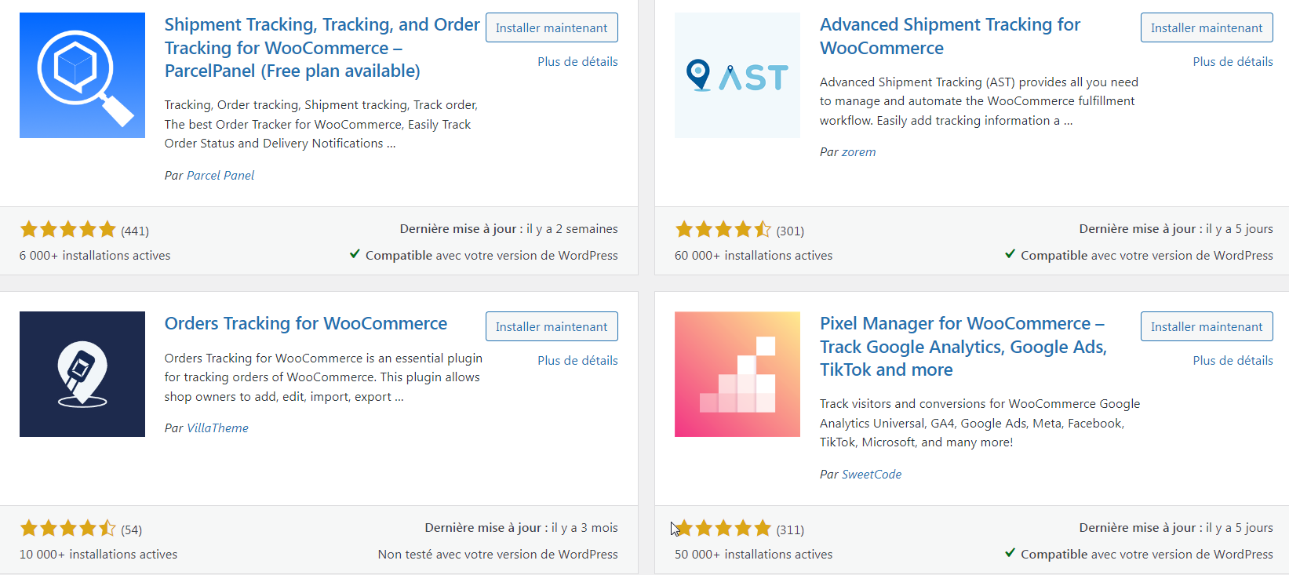

https://www.sendcloud.fr/fonctionnalites/suivi/
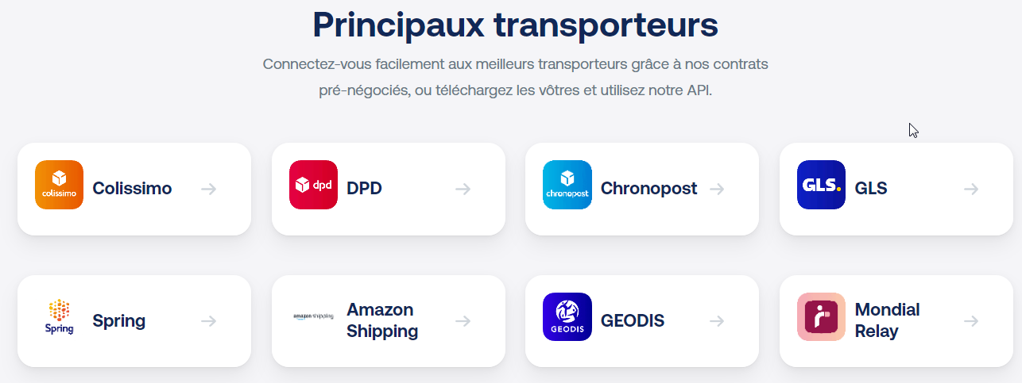

https://www.wcmultishipping.com/mondial-relay-woocommerce#configurer
https://blog.getbyrd.com/fr/9-services-de-livraison-de-colis-populaires-en-france

https://www.youtube.com/watch?v=Sres3dR4_ls
https://www.youtube.com/watch?v=FfLjDlHYxQw&t=35s
https://www.youtube.com/watch?v=shAUxduEbi4
https://www.youtube.com/watch?v=shAUxduEbi4&list=PLwH7LnWMIZ9Y2wi12zvQTpeVIqNHaqJg2

Boxtal
https://www.youtube.com/watch?v=EL-C1ExZO1g

coliship (site interface laposte) pour quelques colis
sinon on préfère sendcloud
https://www.youtube.com/watch?v=ZHWIF1fbzdQ

order tracking
tracking code ???

https://www.youtube.com/@Ambitious-lady plein de vidéos sir le ecommerce

relais colis
mondial relay
https://support.sendcloud.com/hc/fr/articles/360025513452-Les-points-relais-avec-Woocommerce
https://help.boxtal.com/fr/fr/article/configuring-parcel-point-map-bc-wc

https://mondialrelay-wp.com/
https://mondialrelay-wp.com/doc/onglet-configuration/
labelwriter dymmo
https://brunotritsch.fr/expediez-vos-commandes-woocommerce-avec-mondial-relay/

https://wordpress.org/plugins/colissimo-shipping-methods-for-woocommerce/
https://www.colissimo.entreprise.laposte.fr/outils-et-services/modules-et-solutions-e-commerce/solution-e-commerce-woocommerce
coliship
https://www.colissimo.entreprise.laposte.fr/nos-contrats
https://www.mondialrelay.fr/solutionspro/offres-et-services/offre-start/
il faut un numéro siret

https://www.chronopost.fr/fr/woocommerce

https://www.codeur.com/tuto/woocommerce/woocommerce-envoyer-colis-point-relais/
https://www.mondialrelay.fr/connexion-inscription/?returnUrl=/solutionspro/creation-compte-pro/

