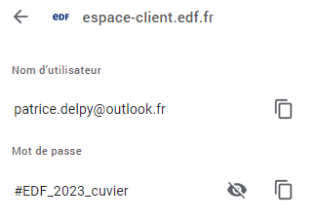
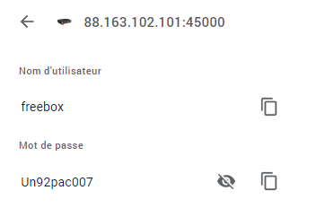

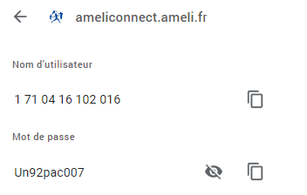




















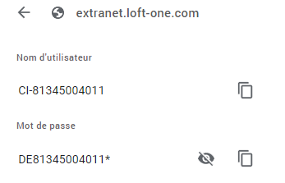





https://discord.com/channels/1121476698899234967/1121476699494821980

#EngieCuvier2023
#EngieCuvier2023

.woocommerce-MyAccount-navigation {
display:none;
}

How To Customize The WooCommerce Checkout Page With Elementor & Woolentor

ffmpeg -r 10 -s 1080x1620 -i %03d.jpeg -vcodec libx264 -crf 25 output.mp4

ezgif-frame-%03d.jpg

ffmpeg -r 10 -s 1080x1620 -i ezgif-frame-%03d.jpg -vcodec libx264 -crf 25 output.mp4

ffmpeg -r 10 -s 1890x930 -i ezgif-frame-%03d.jpg -vcodec libx264 -crf 25 output.mp4

Hide other shipping methods when “Free Shipping” is available

How to Show Total Weight in WooCommerce Cart using Custom PHP Code in WordPress Website

#EDF_2023_cuvier

#EDF_2023_cuvier
23177713402885

SM* E* VAL* JÉR* E* CAM*
E1 16 RS SAI* CEC* APP* 16
**********2885

#EngieCuvier2023
#EngieCuvier2023

105 par albi * 2.50

Salut Marc, une boite de dialogue m'a invité à rejoindre la page IC'Alps. Maintenant j'ai un icon sur la barre latérale gauche mais quand je veux voir le contenu

Choose the header opacity during scroll
Choose the background and color during scroll

si on combine l'option du header en mode transparent et le
code ci-dessous, on a une menu sticky / transparent

#site-header.transparent-header {
position: fixed;
transition: background-color .15s ease-in;
}
}

Elementor Sticky Header Change Colour on Scroll - No Code Required
https://www.youtube.com/watch?v=Wm80XjiGmz4

#site-header {
position: absolute;
}

.page-header {
padding-top : 200px;
}

#site-header.medium-header .top-header-wrap,
#site-header.medium-header #site-navigation-wrap
{
background-color: transparent;
}

#site-header.medium-header .is-sticky #site-navigation-wrap
{
background-color: #fff;
}

How to Create a Transparent Header in OceanWP
https://www.youtube.com/watch?v=lYDsIKv1CE0

Free Transparent Header Tutorial in Wordpress - OceanWP Header
https://www.youtube.com/watch?v=VUw5YbeGE9Y

How to create a Transparent Sticky Header in WordPress with Elementor
https://www.youtube.com/watch?v=o24U8d0Mosc

Créer un menu fixe (sticky menu) avec Elementor ou avec du CSS : En 5 minutes seulement !

selector.elementor-sticky--effects{ background-color: rgba(0,0,0,0.5) !important }

Sticky Header with background color alteration | Elementskit | All in one addon for Elementor

How to Change the Color of a Specific Menu Item in WordPress

https://www.youtube.com/@WebMarketingTuto/videos

https://metaforweb.com/site-test-developpement-wordpress/

#f7f5e7

ssh://analogde@ssh.cluster011.hosting.ovh.net:22

ssh analogde@ssh.cluster011.hosting.ovh.net - p 22

Woocommerce Login/Signup popup ( XootiX )

<i class="fa-solid fa-house" style="color: #000000;"></i>

Bypass “Are you sure you want to log out?” message in WooCommerce

[user_registration_login redirect_url= "https://www.domaine.analog-design.net/aaa/"]
https://www.domaine.analog-design.net/aaa/

