http://www.stanford.edu/class/ee183/handouts_win2003/
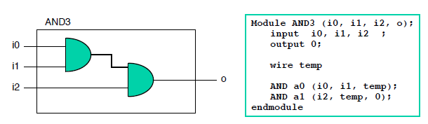
Déclaration :
- Net : wire
- Registre : reg
- reg r; // 1-bit reg variable
- wire w1, w2; // 2 1-bit wire variable
- reg [7:0] vreg; // 8-bit register
- reg [7:0] memory [0:1023]; a 1 KB memory

Représentation des nombres
– 4'b0011 // 4-bit binary number 0011
– 5'd3 // 5-bit decimal number
– 32’hdeadbeef // 32 bit hexadecimal number
Assign
Initial
Always
Begin
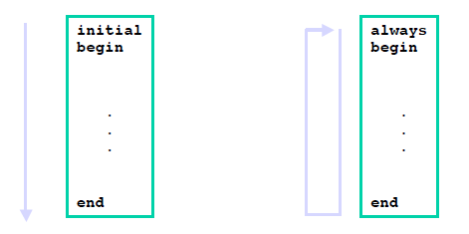

Assignement procédurale
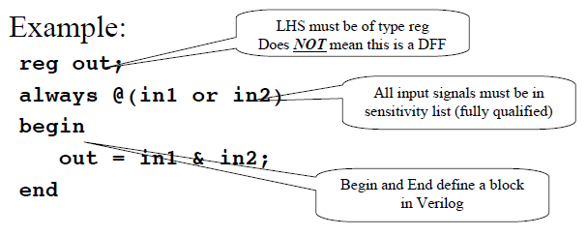
Condition If-else
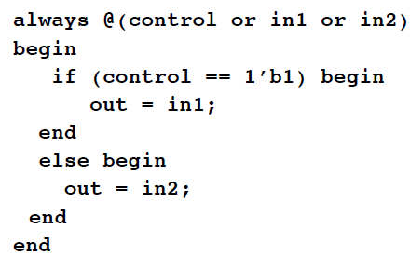

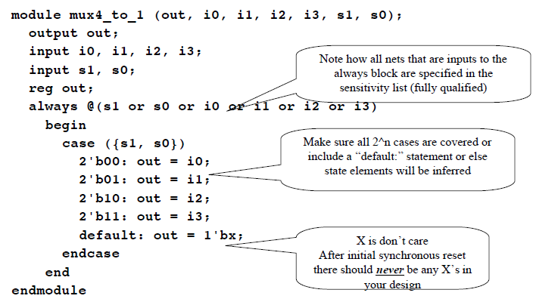
Boucle

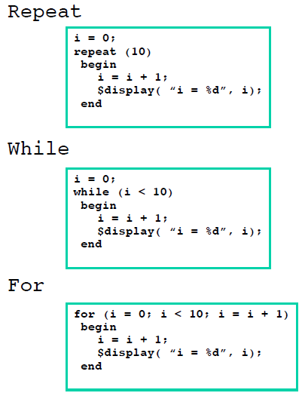
Input / Output pour Xilinx
NET “button” LOC = P80;
NET “out<0>” LOC = P83;
http://www.stanford.edu/class/ee183/handouts_win2003/VerilogQuickRef.pdf

always @ (posedge clock)
begin : COUNTER // Bloc
// a chaque front montant de l’horloge on regarde si le reset est actif
// si reset est actif, on charge le compteur avec "0000"
if (reset == 1'b1) begin
counter_out <= #1 4'b000;
end
// si enable est actif , on incremente
else if (enable == 1'b1) begin
counter_out <= #1 counter_out + 1;
end
end // End of Block COUNTER
endmodule // End of Module counter
Every positive edge of the clock
always @ (posedge clk)
if (rst == 0) if rst port is pressed

state <= 8'b11111111;
else
state [0] <= 0;
endmodule

module exercise1 (clk, rst, led);
input clk, rst; input ports
reg [7:0] state; output port register
output [7:0] led; output ports
assign led = state; output port has the same contents as state

module exercise2 (clk, rst, led);
input clk, rst;
reg [7:0] state;
reg [23:0] counter;
output [7:0] led;
assign led = state;
always @ (posedge clk)
if (rst == 0)
counter <= 0;
else if (counter == 8000000)
counter <= 0;
else
counter <= counter+1;
always @ (posedge clk)
if (rst == 0)
state <= 8'b11111111;
else if (counter == 8000000)
state [0] = ~state [0];
endmodule

Controler une led avec un interrupteur (switches)
always @ (posedge clk)
begin
sw_not <= ~sw;
trig <= sw & sw_not;
end

///////////////////////////////////////////////////////////////
module exercise6 (clk,rst,m1,m2,m3,m4,a,b,c,d,e,f, g,dp);
input clk, rst;
reg [3:0] state;
reg [6:0] number;
output m1, m2, m3, m4, a, b, c, d, e, f, g, dp;
parameter number4 = 7'b1001100;
assign {m4, m3, m2, m1} = state;
assign {a, b, c, d, e, f, g} = number;
assign dp = 1;
always @ (posedge clk)
if (rst == 0)
state <= 4'b0000;
else
state <= 4'b0001;
always @ (posedge clk)
if (rst == 0)
number <= 7'h7f;
else
number <= number4;
endmodule

