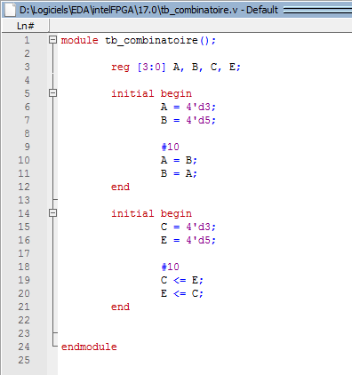

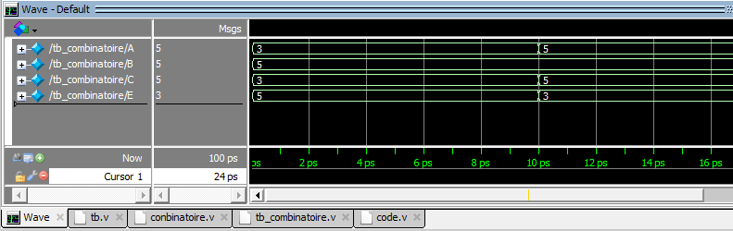

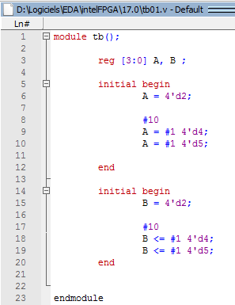

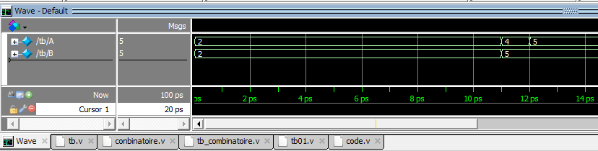

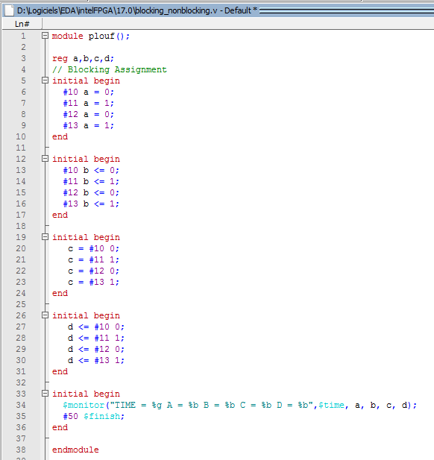

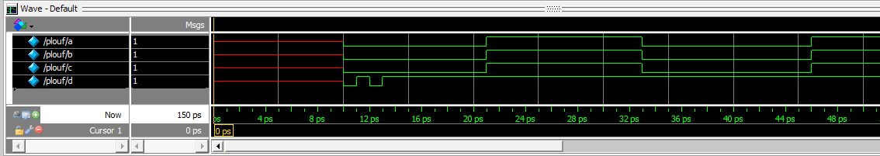
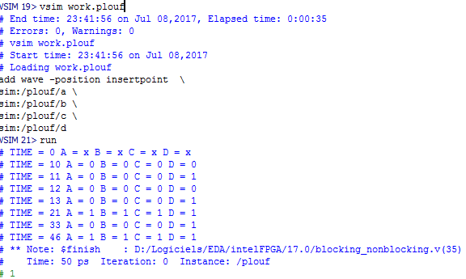

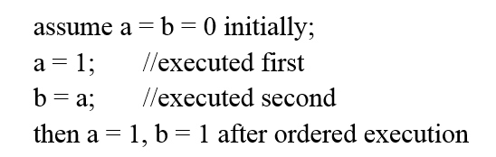

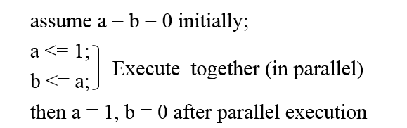

Encodeur 8 vers 3
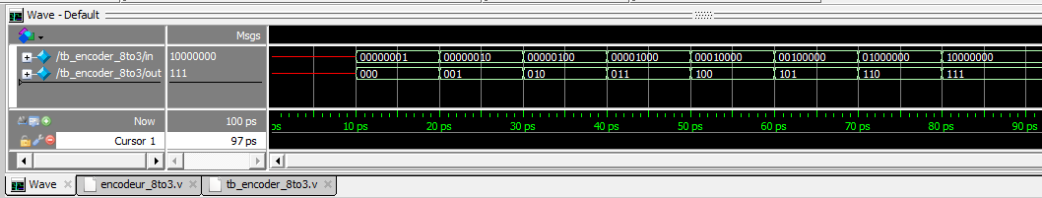

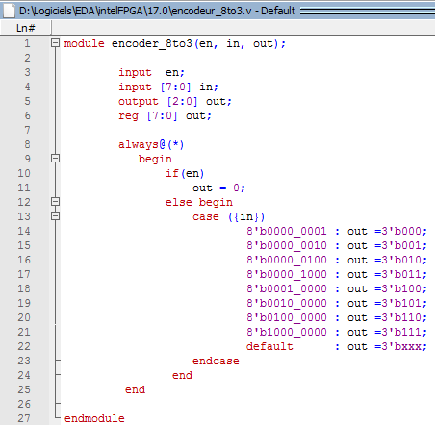

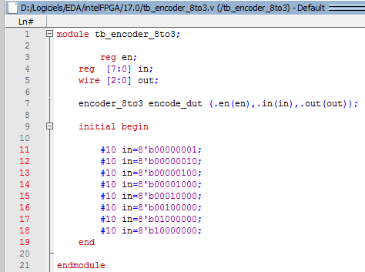

Decodeur 3 vers 8

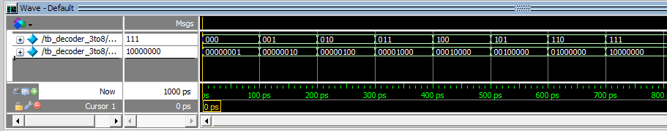

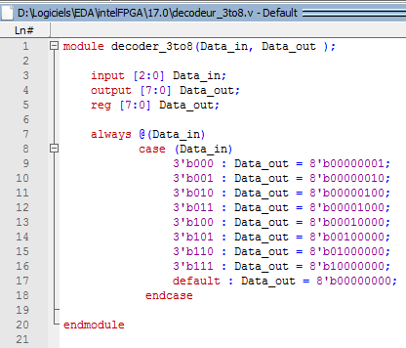

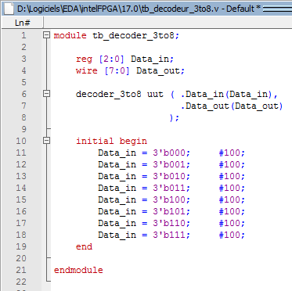

Multiplexeur

https://vlsimaster.wordpress.com/category/vhdl/verilog-code-for-encoder-and-testbench/
http://verilogcodes.blogspot.fr/2015/10/verilog-code-for-digital-clock.html
http://www.testbench.in/verilog_basic_examples.html
module demux1to4(Data_in, sel, Data_out);
input Data_in;
input [1:0] sel;
output Data_out[3:0];
reg Data_out[3:0];
//always block with Data_in and sel in its sensitivity list
always @(Data_in or sel)
begin
case (sel) //case statement with "sel"
//multiple statements can be written inside each case.
//you just have to use 'begin' and 'end' keywords as shown below.
2'b00 : begin
Data_out_0 = Data_in;
Data_out_1 = 0;
Data_out_2 = 0;
Data_out_3 = 0;
end
2'b01 : begin
Data_out_0 = 0;
Data_out_1 = Data_in;
Data_out_2 = 0;
Data_out_3 = 0;
end
2'b10 : begin
Data_out_0 = 0;
Data_out_1 = 0;
Data_out_2 = Data_in;
Data_out_3 = 0;
end
2'b11 : begin
Data_out_0 = 0;
Data_out_1 = 0;
Data_out_2 = 0;
Data_out_3 = Data_in;
end
endcase
end
endmodule

http://verilogcodes.blogspot.fr/2015/10/verilog-code-for-14-demux-using-case.html

module
mux4to1(data, select, out);
input [3:0]
data;
input [1:0]
select;
output
out;
reg
out;
always@(data,select)
case(select)
2’b00: out = data[0];
2’b01: out = data[1];
2’b10: out = data[2];
2’b11:out = data[3];
endcase
endmodule

https://vlsimaster.wordpress.com/2013/01/26/verilog-code-for-4-bit-mux-and-test-bench/

Multiplexeur 4 to 1

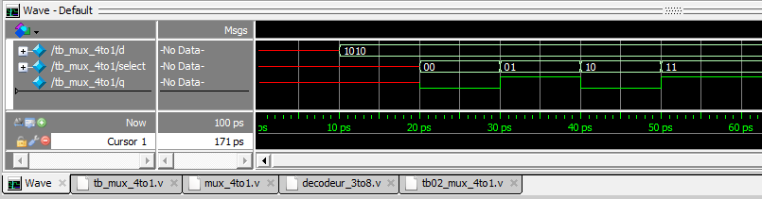

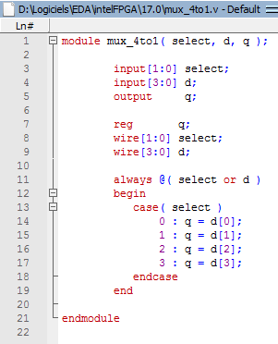

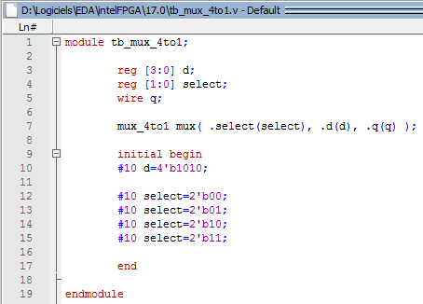

Demultiplexeur 1 vers 4
http://verilogcodes.blogspot.fr/2015/10/verilog-code-for-14-demux-using-case.html

http://www.techmasterplus.com/verilog/demultiplexer.php
module demux (in, sel, out);
input in;
input [1:0] sel;
output [3:0] out;

assign out = in << sel;
endmodule

http://www.edaboard.com/thread106724.html

https://ba.mirror.garr.it/1/groundup/a36.html

