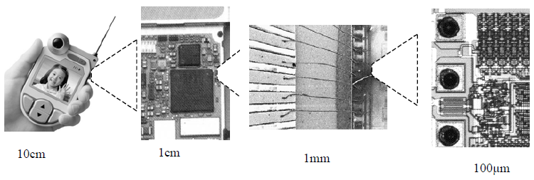
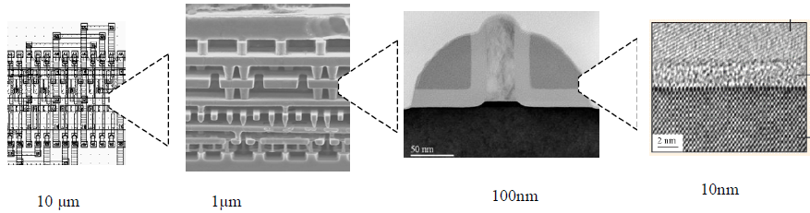

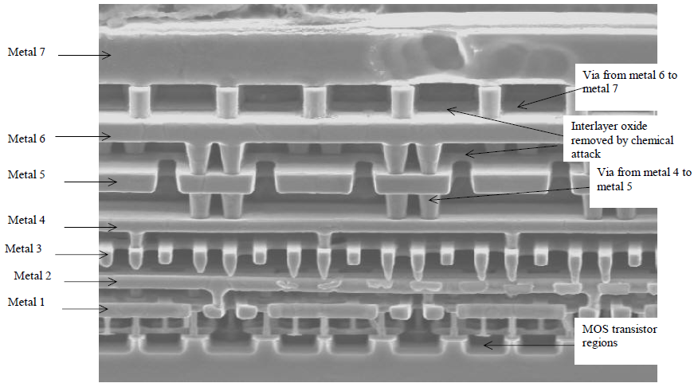

Design rules
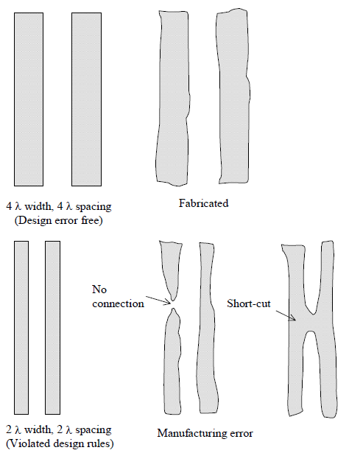

Crosstalk effects in interconnects
Coupling Increased with scale down

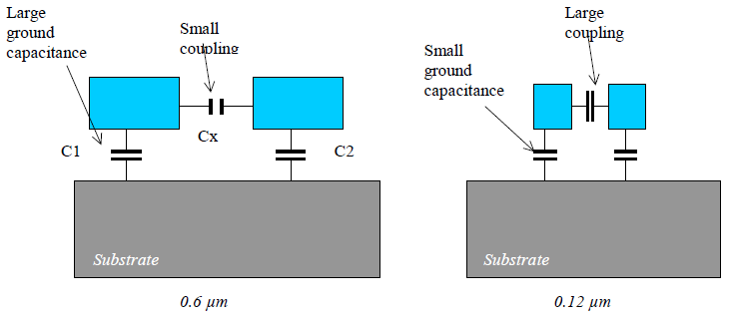
The scale down tends to increase lateral coupling and decrease vertical coupling

Signal propagation
Interconnect
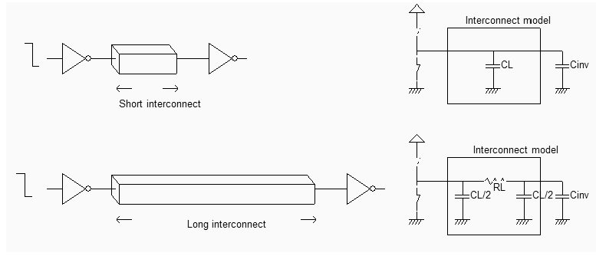
The RC effect of the interconnect appears very clearly in the analog simulation
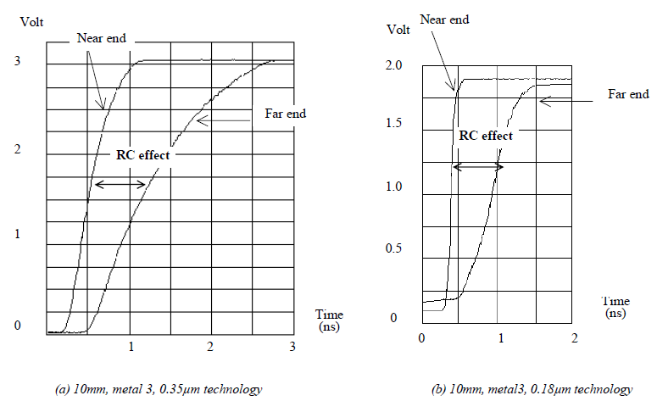

Improved signal transport = increased current drive
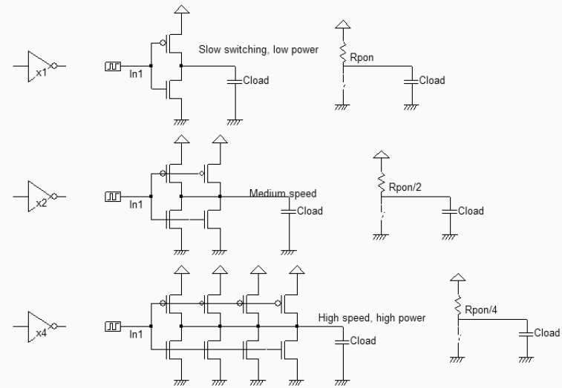

Antenna rules

During the fabrication of interconnects, charges may accumulate and endanger the MOS gate by forcing current
through the gate oxide [Hastings]. This effect, called antenna effect, appears on long metal interconnects connected to
small gate oxide areas, without any path to diffusion. The antenna effect is particularly important in deep submicron
technology: without any possible discharge path, the interconnect accumulates sufficient charges to rise its potential to
several volts, positive or negative depending on the nature of the chemical process step. Usually, plasma etching
charges the interconnect with electrons, corresponding to a negative charge with respect to the substrate ground
voltage.
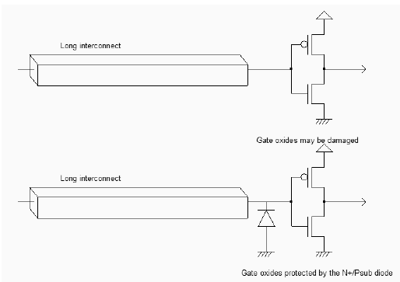
Inserting a diode to discharge the interconnect during plasma etching (AntennaRules.SCH)

Inductance
The inductance effect is not significant in signal transport because of the high serial resistance of interconnects
Notice the ringing effect due to the combination of inductance and capacitance at the far end
of the interconnect
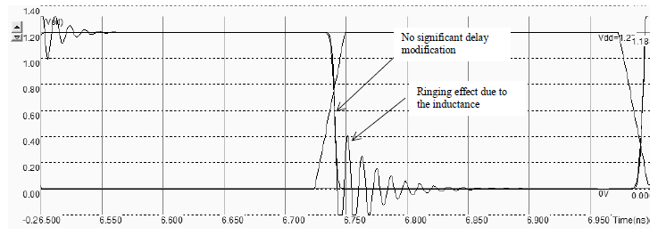

Ringing !!!!!!

What is Electromigration???
Electromigration is the gradual displacement of metal atoms in a semiconductor. It occurs when the current density is high enough to cause the drift of metal ions in the direction of the electron flow, and is characterized by the ion flux density. This density depends on the magnitude of forces that tend to hold the ions in place, i.e., the nature of the conductor, crystal size, interface and grain-boundary chemistry, and the magnitude of forces that tend to dislodge them, including the current density, temperature and mechanical stresses.

Failure mechanism
There are two different EM failure mechanisms that occur due to asymmetry in the ion flow. The first example in Figure shows a void where the outgoing ion flux exceeds the incoming ion flux, resulting in an open circuit. The second example shows a hillock where the incoming ion flux exceeds the outgoing ion flux, resulting in a short circuit

Electromigration (EMG) is a consequence of miniaturization of integrated circuits in general and the reduction of interconnect dimensions in particular. It is identified as one of the critical reliability phenomenon for integrated circuits designed in submicron technologies. The methods of checking this phenomenon at design level are mostly based on current density rules and temperature. These rules are becoming difficult to implement due to increasing current density in interconnection network. This thesis is based on researching for ways to improve detection of electromigration risks at design level. The goal is to establish a relation between electrical rules and interconnect degradation mechanism. Results obtained from ageing tests permit us to relax current limit without altered circuit lifetimes. Finally, this project has been instrumental to define design rules based on optimization of clock tree cells placement in integrated circuit power grid. The application of solution proposed during this work permit to design robust circuits toward EMG.

Current density
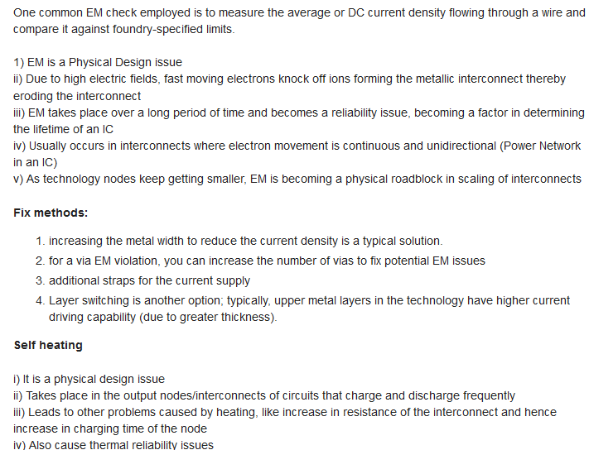

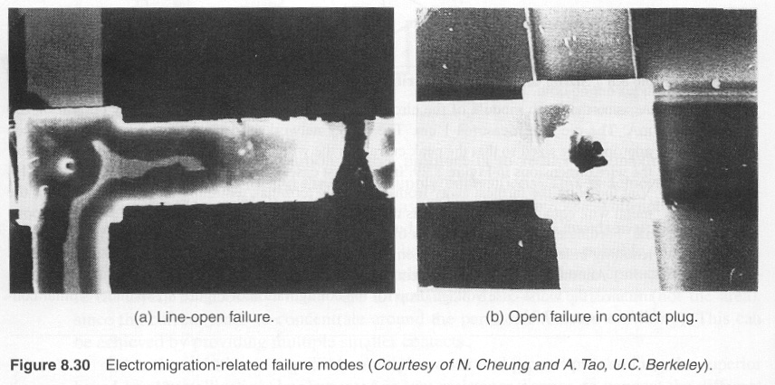

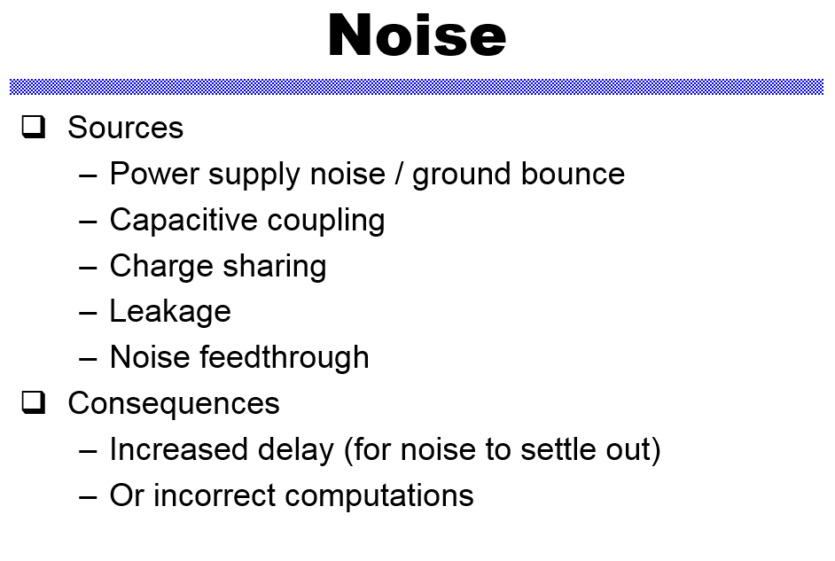

Power distribution

Reliability in CMOS IC Design robustness
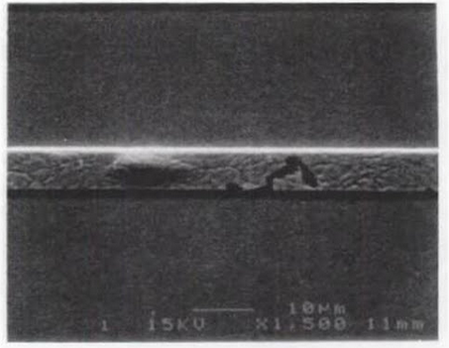

http://pages.hmc.edu/harris/cmosvlsi/4e/index.html

IR-Drop Analysis Results for 2D and 3D Designs

