https://learn.adafruit.com/drive-a-16x2-lcd-directly-with-a-raspberry-pi

MCP230xx GPIO Expander on the Raspberry Pi
Add 8 or 16 extra GPIO pins to your pia via I2C
http://crumpspot.blogspot.be/2013/05/using-3x4-matrix-keypad-with-raspberry.html
#include <Password.h>
#include <LiquidCrystal.h>
#include <Keypad.h>
LiquidCrystal lcd(2,3,4,9,10,11,12);
Password password = Password( "4321" );
const byte ROWS = 4; // Four rows
const byte COLS = 3; // Three columns
// Define the Keymap
char keys[ROWS][COLS] = {
{'1','2','3',},
{'4','5','6',},
{'7','8','9',},
{'*','0',' ',}
};
// Connect keypad ROW0, ROW1, ROW2 and ROW3 to these Arduino pins.
byte rowPins[ROWS] = {25, 24, 23, 22}; //connect to the row pinouts of the keypad
byte colPins[COLS] = {28, 27, 26}; //connect to the column pinouts of the keypad
const int buttonPin = 7;
int buttonState = 0;
// Create the Keypad
Keypad keypad = Keypad( makeKeymap(keys), rowPins, colPins, ROWS, COLS );
#define ledPin 13
void setup(){
pinMode(buttonPin, INPUT);
lcd.begin(16, 2);
digitalWrite(ledPin, LOW); // sets the LED on
Serial.begin(9600);
keypad.addEventListener(keypadEvent); //add an event listener for this keypad
keypad.setDebounceTime(250);
}
void loop(){
keypad.getKey();
buttonState = digitalRead(buttonPin);
if (buttonState == HIGH) {
lcd.clear();
}
}
//take care of some special events
void keypadEvent(KeypadEvent eKey){
switch (keypad.getState()){
case PRESSED:
lcd.print(eKey);
switch (eKey){
case ' ': guessPassword(); break;
default:
password.append(eKey);
}
}}
void guessPassword(){
if (password.evaluate()){
digitalWrite(ledPin,HIGH); //activates garaged door relay
delay(500);
digitalWrite(ledPin,LOW); //turns off door relay after .5 sec
lcd.print("VALID PASSWORD "); //
password.reset(); //resets password after correct entry
delay(600);
lcd.print("Welcome");
delay(2000);
lcd.clear();
}
else{
digitalWrite(ledPin,LOW);
lcd.print("INVALID PASSWORD ");
password.reset(); //resets password after INCORRECT entry
delay(600);
lcd.clear();
}
}
http://www.instructables.com/id/Password-Lock-with-Arduino/step4/Code/
http://www.electronics123.net/amazon/projects/Electronics123_Door_Lock_Project/Arduino_Door_Lock.html
http://www.newtechandme.com/arduino/arduino-tutorial-lesson-3-2-keypad-and-lcd-with-password/
http://www.newtechandme.com/arduino/arduino-tutorial-lesson-3-1-keypad-and-lcd/
https://sites.google.com/site/arduinomega2560projects/home/level-3/keymembrane-and-lcd-password-lock

https://github.com/rohankapoorcom/ElectronicLock door lock

// Python code for detecting Rising Edge
import RPi.GPIO as GPIO
import time
import os

#adjust for where your switch is connected
buttonPin = 17
GPIO.setmode(GPIO.BCM)
GPIO.setup(buttonPin,GPIO.IN)

while True:
#assuming the script to call is long enough we can ignore bouncing
if (GPIO.input(buttonPin)):
#this is the script that will be called (as root)
os.system("python /home/pi/start.py")

- import RPi.GPIO as GPIO # import RPi.GPIO module
- GPIO.setmode(GPIO.BCM) # choose BCM or BOARD
- GPIO.setup(port_or_pin, GPIO.OUT) # set a port/pin as an output
- GPIO.output(port_or_pin, 1) # set port/pin value to 1/GPIO.HIGH/True
- GPIO.output(port_or_pin, 0) # set port/pin value to 0/GPIO.LOW/False

- import RPi.GPIO as GPIO # import RPi.GPIO module
- from time import sleep # lets us have a delay
- GPIO.setmode(GPIO.BCM) # choose BCM or BOARD
- GPIO.setup(24, GPIO.OUT) # set GPIO24 as an output

- try:
- while True:
- GPIO.output(24, 1) # set GPIO24 to 1/GPIO.HIGH/True
- sleep(0.5) # wait half a second
- GPIO.output(24, 0) # set GPIO24 to 0/GPIO.LOW/False
- sleep(0.5) # wait half a second

- except KeyboardInterrupt: # trap a CTRL+C keyboard interrupt
- GPIO.cleanup() # resets all GPIO ports used by this program

- import RPi.GPIO as GPIO # import RPi.GPIO module
- from time import sleep # lets us have a delay
- GPIO.setmode(GPIO.BCM) # choose BCM or BOARD
- GPIO.setup(24, GPIO.OUT) # set GPIO24 as an output

- try:
- while True:
- GPIO.output(24, 1) # set GPIO24 to 1/GPIO.HIGH/True
- sleep(0.5) # wait half a second
- if GPIO.input(24):
- print "LED just about to switch off"
- GPIO.output(24, 0) # set GPIO24 to 0/GPIO.LOW/False
- sleep(0.5) # wait half a second
- if not GPIO.input(24):
- print "LED just about to switch on"
- except KeyboardInterrupt: # trap a CTRL+C keyboard interrupt
- GPIO.cleanup() # resets all GPIO ports used by this program

http://raspi.tv/2013/how-to-use-interrupts-with-python-on-the-raspberry-pi-and-rpi-gpio-part-3

interruption
import time
import _thread
import RPi.GPIO as GPIO

GPIO.setmode(GPIO.BOARD)

GPIO.setup(11, GPIO.OUT)

def wait_for_input(stop):
input("Press enter to stop blinking.")
stop.append(True)
print("Stopping the blinking.")

def blink():
stop = []
_thread.start_new_thread(wait_for_input, (stop,))
while True:
GPIO.output(11, True)
time.sleep(2)
GPIO.output(11, False)
time.sleep(2)
if stop: break

blink()

GPIO.cleanup()

http://crumpspot.blogspot.fr/p/keypad-matrix-python-package.html
http://maniacallabs.com/category/dial-a-song/
https://www.cl.cam.ac.uk/projects/raspberrypi/tutorials/robot/face_detection/
http://usualpanic.com/category/raspberry-pi/
http://tronixstuff.com/2013/12/16/arduino-tutorials-chapter-42-numeric-keypads/
http://musicdiver.com/wordpress/2013/01/keypad-code-lock-with-arduino/

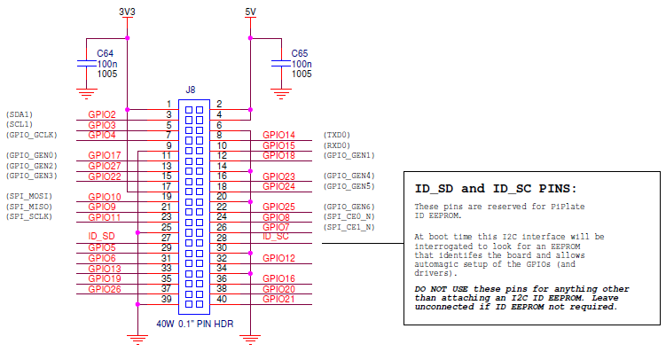

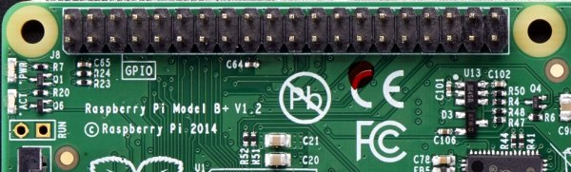

Pour tous ceux qui aiment raccorder des capteurs, des boutons, des écrans et autres accessoires, c’est une bonne nouvelle : il y a 9 broches GPIO supplémentaires
processeur 700MHz Broadcom BCM2835 CPU

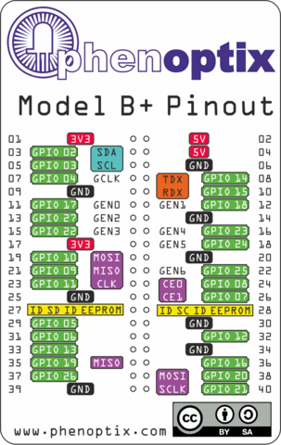
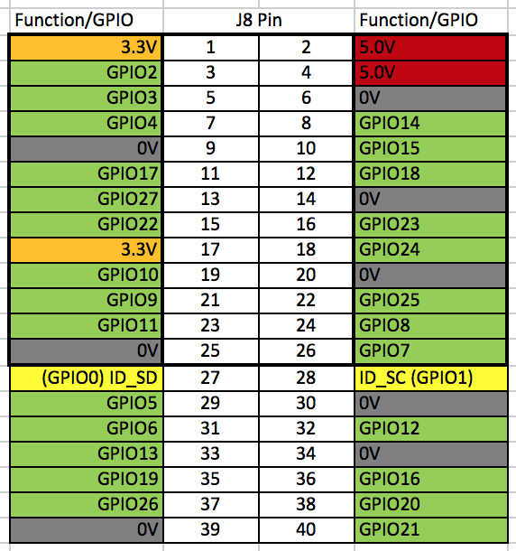

http://www.raspberrypi-spy.co.uk/wp-content/uploads/2014/07/Raspberry-Pi-GPIO-Layout-Worksheet.pdf 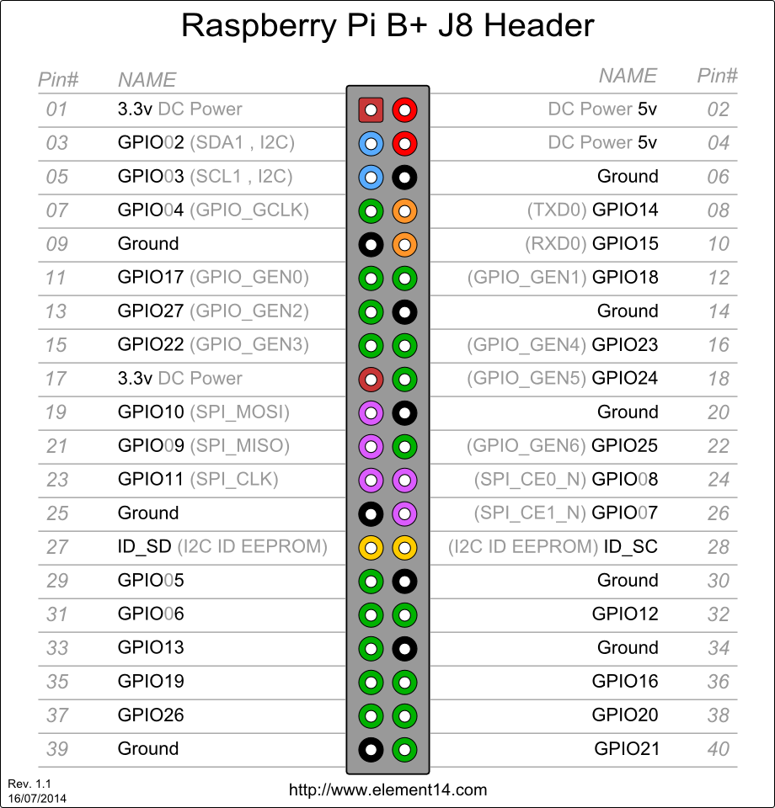
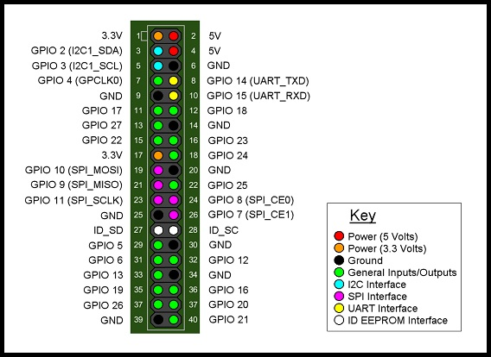
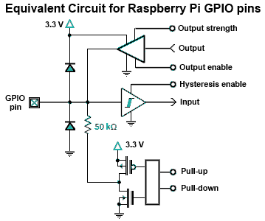

- Pin 7 on the keypad is ROW 0- GPIO 18
- Pin 6 on the keypad is ROW 1- GPIO 23
- Pin 5 on the keypad is ROW 2- GPIO 24
- Pin 4 on the keypad is ROW 3- GPIO 25
- Pin 3 on the keypad is COL 0 - GPIO 4
- Pin 2 on the keypad is COL 1 - GPIO 17 22
- Pin 1 on the keypad is COL 2 - GPIO 22 10
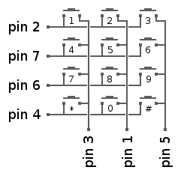

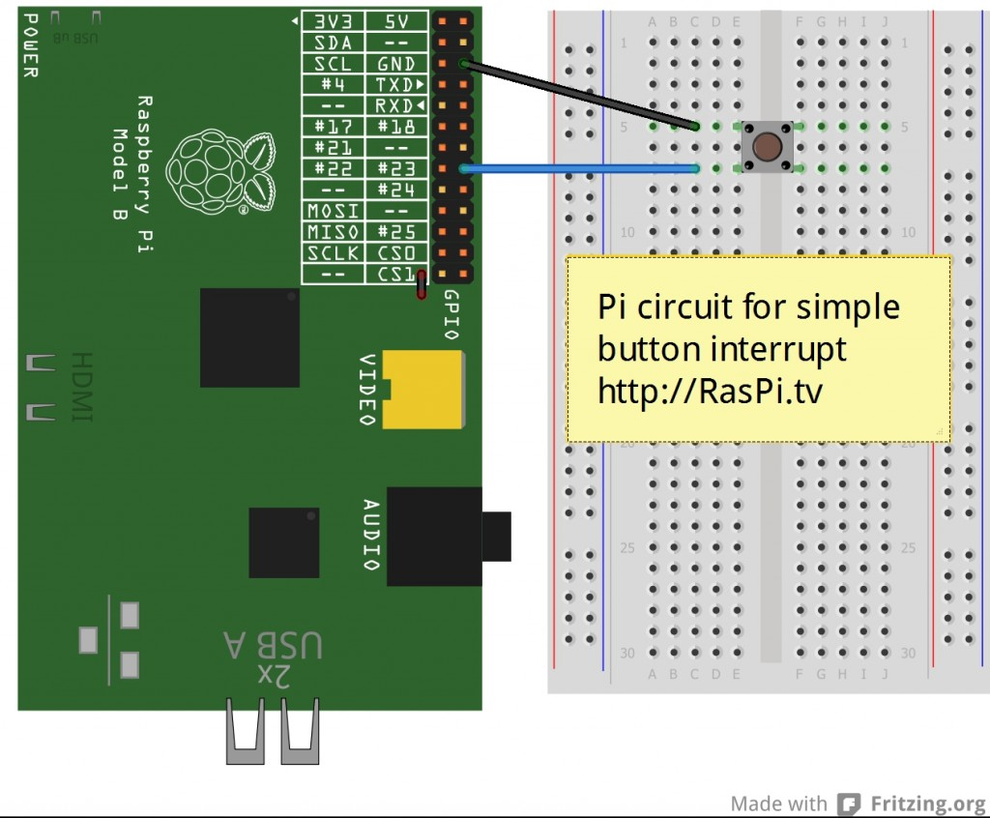

Super intéresant
http://raspi.tv/2013/how-to-use-interrupts-with-python-on-the-raspberry-pi-and-rpi-gpio-part-2

import RPi.GPIO as GPIO
GPIO.setmode(GPIO.BCM)

# GPIO 23 & 24 set up as inputs. One pulled up, the other down.
# 23 will go to GND when button pressed and 24 will go to 3V3 (3.3V)
# this enables us to demonstrate both rising and falling edge detection
GPIO.setup(23, GPIO.IN, pull_up_down=GPIO.PUD_UP)
GPIO.setup(24, GPIO.IN, pull_up_down=GPIO.PUD_DOWN)

# now we'll define the threaded callback function
# this will run in another thread when our event is detected
def my_callback(channel):
print "Rising edge detected on port 24 - even though, in the main thread,"
print "we are still waiting for a falling edge - how cool?\n"

print "Make sure you have a button connected so that when pressed"
print "it will connect GPIO port 23 (pin 16) to GND (pin 6)\n"
print "You will also need a second button connected so that when pressed"
print "it will connect GPIO port 24 (pin 18) to 3V3 (pin 1)"
raw_input("Press Enter when ready\n>")

# The GPIO.add_event_detect() line below set things up so that
# when a rising edge is detected on port 24, regardless of whatever
# else is happening in the program, the function "my_callback" will be run
# It will happen even while the program is waiting for
# a falling edge on the other button.
GPIO.add_event_detect(24, GPIO.RISING, callback=my_callback)

try:
print "Waiting for falling edge on port 23"
GPIO.wait_for_edge(23, GPIO.FALLING)
print "Falling edge detected. Here endeth the second lesson."

except KeyboardInterrupt:
GPIO.cleanup() # clean up GPIO on CTRL+C exit
GPIO.cleanup() # clean up GPIO on normal exit

GPIO.add_event_detect
GPIO.wait_for_edge

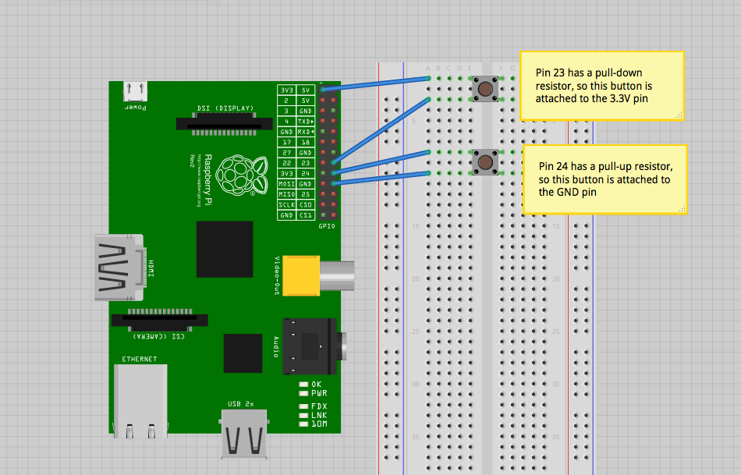

import RPi.GPIO as GPIO
GPIO.setmode(GPIO.BCM)
GPIO.setup(23, GPIO.IN, pull_up_down = GPIO.PUD_DOWN)
GPIO.setup(24, GPIO.IN, pull_up_down = GPIO.PUD_UP)
while True:
if(GPIO.input(23) ==1):
print(“Button 1 pressed”)
if(GPIO.input(24) == 0):
print(“Button 2 pressed”)
GPIO.cleanup()

import RPi.GPIO as GPIO
GPIO.setmode(GPIO.BCM)
GPIO.setup(23, GPIO.IN, pull_up_down = GPIO.PUD_DOWN)
GPIO.setup(24, GPIO.IN, pull_up_down = GPIO.PUD_UP)
def printFunction(channel):
print(“Button 1 pressed!”)
print(“Note how the bouncetime affects the button press”)
GPIO.add_event_detect(23, GPIO.RISING, callback=printFunction, bouncetime=300)
while True:
GPIO.wait_for_edge(24, GPIO.FALLING)
print(“Button 2 Pressed”)
GPIO.wait_for_edge(24, GPIO.RISING)
print(“Button 2 Released”)
GPIO.cleanup()

GPIO.remove_event_detect(23)

http://hardware-libre.fr/2013/07/ajouter-un-bouton-dextinction-avec-python/

pour le lcd
http://www.rpiblog.com/2012/11/interfacing-16x2-lcd-with-raspberry-pi.html

faire clignoter une led 50 fois pendant 1 seconde
- import RPi.GPIO as GPIO
- import time
- # blinking function
- def blink(pin):
- GPIO.output(pin,GPIO.HIGH)
- time.sleep(1)
- GPIO.output(pin,GPIO.LOW)
- time.sleep(1)
- return
- # to use Raspberry Pi board pin numbers
- GPIO.setmode(GPIO.BOARD)
- # set up GPIO output channel
- GPIO.setup(11, GPIO.OUT)
- # blink GPIO17 50 times
- for i in range(0,50):
- blink(11)
- GPIO.cleanup()
https://learn.adafruit.com/downloads/pdf/drive-a-16x2-lcd-directly-with-a-raspberry-pi.pdf
http://www.raspberrypi-spy.co.uk/2012/07/16x2-lcd-module-control-using-python/

Enable
R/W
RS
D4/D5/D6/D7
Clavier 4*3 = 4 lignes * 3 colonnes soit 7 gpios
Total : 14

GPIO.setup(LCD_E, GPIO.OUT) # E
GPIO.setup(LCD_RS, GPIO.OUT) # RS
GPIO.setup(LCD_D4, GPIO.OUT) # DB4
GPIO.setup(LCD_D5, GPIO.OUT) # DB5
GPIO.setup(LCD_D6, GPIO.OUT) # DB6
GPIO.setup(LCD_D7, GPIO.OUT) # DB7

Super : LCD avec I2C //// http://www.recantha.co.uk/blog/?p=4849
http://michlstechblog.info/blog/raspberry-pi-connecting-a-hd44780-display-with-i2c-bus/
http://tech2077.blogspot.fr/2012/06/running-hd44780-lcd-over-i2c-on.html
SUPER à voir http://edsard.nl/projects/raspberry/ LCD avec I2C
Projet intéressant ::::::: http://ikanbilis.com/16.php
http://www.raspberrypi-spy.co.uk/2013/07/how-to-use-a-mcp23017-i2c-port-expander-with-the-raspberry-pi-part-3/

