Test de la caméra :
raspistill -o image.jpg

Installation du package
sudo apt-get install python-picamera python3-picamera python-rpi.gpio

raspivid pour faire une video

import time
import picamera

with picamera.PiCamera() as camera:
camera.start_preview()
time.sleep(5)
camera.capture('/home/pi/Desktop/image.jpg')
camera.stop_preview()

camera.resolution = (1024, 768)

import picamera

with picamera.PiCamera() as camera:
camera.resolution = (640, 480)
camera.start_recording('my_video.h264')
camera.wait_recording(60)
camera.stop_recording()

import picamera

with picamera.PiCamera() as camera:
# Turn the camera's LED off
camera.led = False
# Take a picture while the LED remains off
camera.capture('foo.jpg')

http://www.raspberrypi.org/learning/python-picamera-setup/

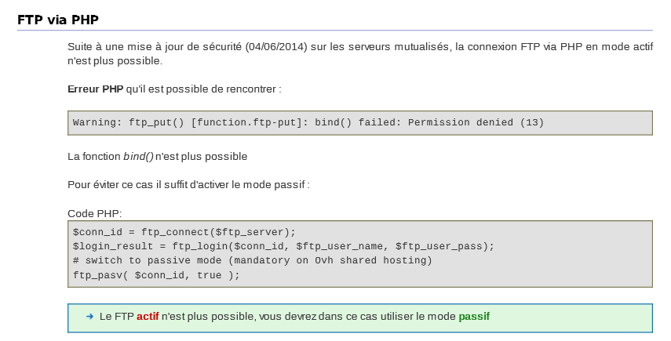

<?php
$file = 'somefile.txt';
$remote_file = 'readme.txt';
// Mise en place d'une connexion basique
$conn_id = ftp_connect($ftp_server);
// Identification avec un nom d'utilisateur et un mot de passe
$login_result = ftp_login($conn_id, $ftp_user_name, $ftp_user_pass);
// Activation du mode passif
ftp_pasv($conn_id, true);
// Chargement d'un fichier
if (ftp_put($conn_id, $remote_file, $file, FTP_ASCII)) {
echo "Le fichier $file a été chargé avec succès\n";
} else {
echo "Il y a eu un problème lors du chargement du fichier $file\n";
}
// Fermeture de la connexion
ftp_close($conn_id);
?>

<?php
// connect and login to FTP server
$ftp_server = "ftp.example.com";
$ftp_conn = ftp_connect($ftp_server) or die("Could not connect to $ftp_server");
$login = ftp_login($ftp_conn, $ftp_username, $ftp_userpass);
// turn passive mode on
ftp_pasv($ftp_conn, true);
$file = "localfile.txt";
// upload file
if (ftp_put($ftp_conn, "serverfile.txt", $file, FTP_ASCII))
{
echo "Successfully uploaded $file.";
}
else
{
echo "Error uploading $file.";
}
// close connection
ftp_close($ftp_conn);
?>

// FTP access parameters
$host = 'ftp.example.org';
$usr = 'example_user';
$pwd = 'example_password';

// file to move:
$local_file = './example.txt';
$ftp_path = '/data/example.txt';

// connect to FTP server (port 21)
$conn_id = ftp_connect($host, 21) or die ("Cannot connect to host");

// send access parameters
ftp_login($conn_id, $usr, $pwd) or die("Cannot login");

// turn on passive mode transfers (some servers need this)
// ftp_pasv ($conn_id, true);

// perform file upload
$upload = ftp_put($conn_id, $ftp_path, $local_file, FTP_ASCII);

// check upload status:
print (!$upload) ? 'Cannot upload' : 'Upload complete';
print "\n";

/*
** Chmod the file (just as example)
*/

// If you are using PHP4 then you need to use this code:
// (because the "ftp_chmod" command is just available in PHP5+)
if (!function_exists('ftp_chmod')) {
function ftp_chmod($ftp_stream, $mode, $filename){
return ftp_site($ftp_stream, sprintf('CHMOD %o %s', $mode, $filename));
}
}

// try to chmod the new file to 666 (writeable)
if (ftp_chmod($conn_id, 0666, $ftp_path) !== false) {
print $ftp_path . " chmoded successfully to 666\n";
} else {
print "could not chmod $file\n";
}

// close the FTP stream
ftp_close($conn_id);

http://fr.openclassrooms.com/informatique/cours/interagir-avec-le-serveur-ftp

