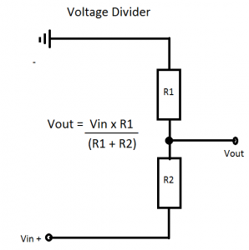
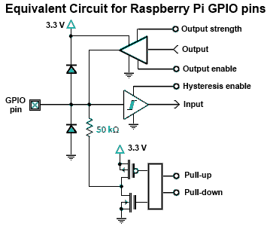

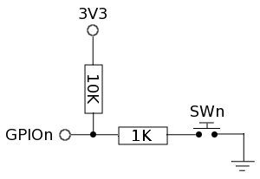

- Alarme hors service : désactive (disabled) la sortie donc GPIO est à 3.3V
- Mise en service : (enable) active la sortie et fixe un niveau Low

http://plomteuxkevin.wordpress.com/2013/03/16/les-gpio/

http://jeremyblythe.blogspot.co.uk/2012/06/motion-google-drive-uploader-and.html
http://www.classthink.com/2014/01/12/raspberry-pi-vocal-intruder-warning-system-project/

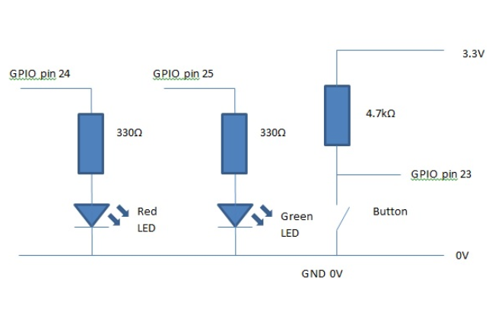

#!/usr/bin/env python

import time
import RPi.GPIO as GPIO

def main():

# tell the GPIO module that we want to use the
# chip's pin numbering scheme
GPIO.setmode(GPIO.BCM)

# setup pin 25 as an output
GPIO.setup(23,GPIO.IN)
GPIO.setup(24,GPIO.OUT)
GPIO.setup(25,GPIO.OUT)

GPIO.output(25,True)

while True:
if GPIO.input(23):
# the button is being pressed, so turn on the green LED
# and turn off the red LED
GPIO.output(24,True)
GPIO.output(25,False)
print "button true"
else:
# the button isn't being pressed, so turn off the green LED
# and turn on the red LED
GPIO.output(24,False)
GPIO.output(25,True)
print "button false"

time.sleep(0.1)

print "button pushed"

GPIO.cleanup()

if __name__=="__main__":
main()

le programme ci-dessous utilise le mode interruption pour capturer l’évènement « appui sur bouton »

#!/usr/bin/env python

import time
import RPi.GPIO as GPIO

# handle the button event
def buttonEventHandler (pin):
print "handling button event"

# turn the green LED on
GPIO.output(25,True)

time.sleep(1)

# turn the green LED off
GPIO.output(25,False)

# main function
def main():

# tell the GPIO module that we want to use
# the chip's pin numbering scheme
GPIO.setmode(GPIO.BCM)

# setup pin 23 as an input
# and set up pins 24 and 25 as outputs
GPIO.setup(23,GPIO.IN)
GPIO.setup(24,GPIO.OUT)
GPIO.setup(25,GPIO.OUT)

# tell the GPIO library to look out for an
# event on pin 23 and deal with it by calling
# the buttonEventHandler function
GPIO.add_event_detect(23,GPIO.FALLING)
GPIO.add_event_callback(23,buttonEventHandler,100)

# turn off both LEDs
GPIO.output(25,False)
GPIO.output(24,True)

# make the red LED flash
while True:
GPIO.output(24,True)
time.sleep(1)
GPIO.output(24,False)
time.sleep(1)

GPIO.cleanup()

if __name__=="__main__":
main()

if __name__ == '__main__' est un un idiome qu’on voit souvent dans les scripts Python.

http://raspberrywebserver.com/cgiscripting/sending-data-to-an-HTTP-server-get-and-post-methods.html
http://sourceforge.net/p/raspberry-gpio-python/wiki/Inputs/
• sudo apt-get install alsa-utils
• $ sudo apt-get install mpg321

• sudo modprobe snd_bcm2835
• $ sudo amixer cset numid=3 1

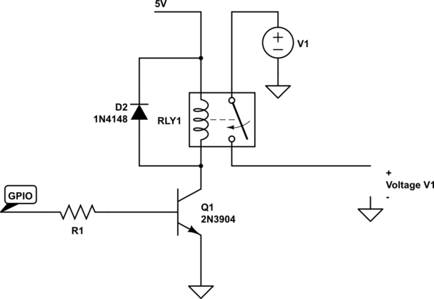

GPIO.setup(23, GPIO.IN, pull_up_down=GPIO.PUD_DOWN)
GPIO.setup(24, GPIO.IN, pull_up_down=GPIO.PUD_UP)
# A rising-edge is defined by the time the pin changes from low to high, but it only detects the change.
# Similarly, the falling-edge is the moment the pin changes from high to low.
GPIO.wait_for_edge(23, GPIO.RISING)
GPIO.wait_for_edge(24, GPIO.FALLING)

GPIO.add_event_detect(23, GPIO.RISING, callback=printFunction, bouncetime=300)

?????? GPIO.add_event_callback
GPIO.cleanup()
Events let you remove them from a pin just as easily as you can add them :
GPIO.remove_event_detect(23)

