Win32 Disk Imager : SD card flashing
NBOOS: plusieurs distribution
sudo raspi-config
startx
sudo reboot
Pour adapter la résolution de l'écran fournit par le RaspberryPi, il faut éditer le fichier /boot/config.txt
framebuffer_width=800
framebuffer_height=600
LXDE : environnement allégué
nano : editeur en ligne de commande gnu
sudo shutdown -h now
sudo apt-get update
sudo apt-get upgrade
sudo apt-get install
sudo apt-get update && sudo apt-get upgrade
cat /boot/config.txt
nano /usr/bin/raspi-config
sudo apt-get install xfce4

192.168.1.0
Masque 255.255.250.0
ifconfig : inet adress
route : table de routage

Par défaut, le mode dhcp est actif. Si on veut avoir une adresse ip fixe il faut éditer le fichier :
sudo nano /etc/network/interfaces
Et faire le changement suivant
iface eth0 inet dhcp -> iface eth0 inet static

Advanced IP Scanner

SSH: PuTTY
Port 22
/etc/.ssh/known_hosts configuration file

VNC : sudo apt-get install tightvncserver

tightvncserver

vncserver :2 -geometry 1024x768 -depth 24

Pour lancer VNC automatiquement :

cd ~/.config
mkdir autostart
cd autostart
sudo nano tightvnc.desktop

Type = Application
Name = TightVNC
Exec = vncserver :1
StartupNotify = false

Tkinter : interface graphique

sudo apt-get update
sudo apt-get dist-upgrade
sudo apt-get install python3-rpi.gpio
sudo apt-get install chromium
sudo apt-get install synaptic
sudo apt-get install geany

Configuration en serveur WEB : LAMP
sudo apt-get install apache2 php5 libapache2-mod-php5
sudo service apache2 restart
cat /var/www/index.html
http://localhost
cd /var/www
Creation du fichier php : sudo nano phpinformation.php
<?php phpinfo();?>
http://localhost/phpinformation.php

Mysql:
sudo apt-get install mysql-server mysql-client php5-mysql

Vérification de l’installation de Mysql : sudo /etc/init.d/mysql status
MySQL stores its configuration settings in /etc/mysql/my.cnf.
PHP stores its settings in /etc/php5/apache2/php.ini.

Logiciel FTP:
sudo apt-get install vsftpd
sudo nano /etc/vsftpd.conf
Anonymous_enable=NO
Local_enable=YES
Write_enable=YES
Ascii_upload_enable=YES
Ascii_download_enable=YES
sudo /etc/init.d/vsftpd restart

Installation de Phpmyadmin
apt-get install phpmyadmin
sudo nano /etc/apache2/apache2.conf
Include /etc/phpmyadmin/apache.conf
sudo /etc/init.d/apache2 restart
http://localhost/phpmyadmin

Piloter les ports GPIO à partir d’un navigateur internet
web.py

Drive your Raspberry Pi with a mobile phone

http://www.themagpi.com/issue/issue-9/article/the-python-pit-drive-your-raspberry-pi-with-a-mobile-phone/
http://newfreshpeace.blogspot.fr/2013/01/raspberry-pi-gpio-web-interface-using.html
http://cloud101.eu/blog/2012/04/24/python-for-the-web-with-webpy/#more-

Controlling The Raspberry Pi GPIO With A Web Interface

GPIO-Ports via PHP-Script
https://www.modmypi.com/blog/tutorial-how-to-give-your-raspberry-pi-a-static-ip-address
+++++++++ http://server2.herokuapp.com/gs_pi_remote.html
+++++++++ http://www.diverteka.com/?p=1492
+++++++++ https://code.google.com/p/raspberrypi-gpio/
+++++++++ http://www.instructables.com/id/Web-Control-of-Raspberry-Pi-GPIO/
+++++++++ http://blog.idleman.fr/raspberry-pi-06-utiliser-le-gpio-et-interagir-avec-le-monde-reel/
http://www.raspberrypi.org/forums/viewtopic.php?f=26&t=27830
++++++++ http://elinux.org/Rpi_Low-level_peripherals
http://pautex.fr/domotique/raspberrypi.php

++++++++ http://www.instructables.com/id/Simple-and-intuitive-web-interface-for-your-Raspbe/step4/Controlling-the-LEDs-with-PHP/

<?php
system ( "gpio mode 0 out" );
system ( "gpio write 0 1" );
?>

<?php
exec ( "gpio read 0", $status );
print_r ( $status );
?>

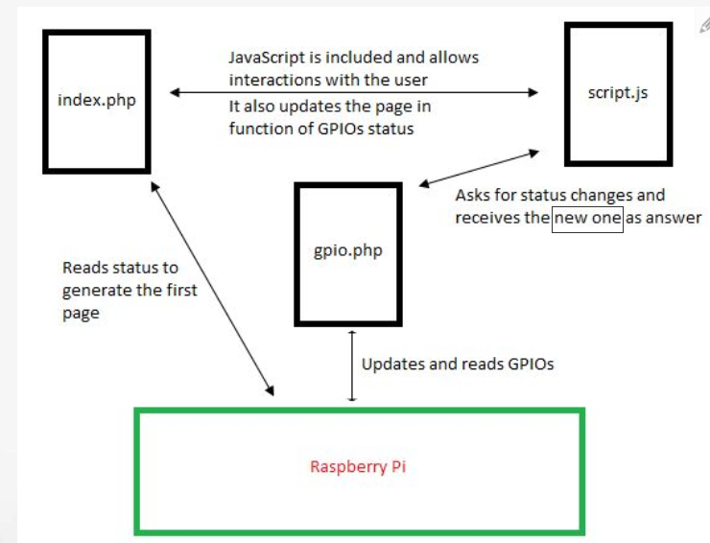

Simple and intuitive web interface for your Raspberry Pi

<?php
$status = array ( 0 );
//set pins mode to output
for ($i = 0; $i <= 7; $i ) {
system ( "gpio mode ".$i." out" );
}
//turns on the LEDs
for ($i = 0; $i <= 7; $i ) {
system ( "gpio write ".$i." 1" );
}
//reads and prints the LEDs status
for ($i = 0; $i <= 7; $i ) {
exec ( "gpio read ".$i, $status );
echo ( $status[0] );
}
//waits 2 seconds
sleep ( 2 );
//turns off the LEDs
for ($i = 0; $i <= 7; $i ) {
system ( "gpio write ".$i." 0" );
}
?>

https://github.com/ronanguilloux/php-gpio
++++++++ http://papinthierry.free.fr/index.php?option=com_content&view=article&id=31&Itemid=27

<?php

if ($_POST['initialized']!=1) {
echo "Initializing port<br>";
exec("echo 9 > /sys/class/gpio/export", $output, $return);
exec("echo out > /sys/devices/virtual/gpio/gpio9/direction", $output, $return);
}

if ($_POST['led']==2) {
echo "Led ON";
exec("echo 1 > /sys/devices/virtual/gpio/gpio9/value", $output, $return);

}

if ($_POST['led']==1) {
echo "Led OFF";
exec("echo 0 > /sys/devices/virtual/gpio/gpio9/value", $output, $return);
}

?>

<form method="post">
<input type="hidden" name="led" value="2">
<input type="hidden" name="initialized" value="1">
<input type="submit" name="submit" value="Led ON"><br>
</form>

<form method="post">
<input type="hidden" name="led" value="1">
<input type="hidden" name="initialized" value="1">
<input type="submit" name="submit" value="Led OFF"><br>
</form>

http://www.element14.com/community/community/designcenter/single-board-computers/next-gen_beaglebone/blog/2013/11/22/beaglebone-web-server--led-blinking
++++++++ http://www.bmc.med.utoronto.ca/bmcwiki/doku.php/technology:media_technologies:web_applications_for_the_raspberry_pi#ajax_jquery_led_controller

http://www.linuxuser.co.uk/tutorials/remotely-control-your-raspberry-pi

control your raspberry over internet

++++++++++ http://jack.minardi.org/raspberry_pi/make-an-internet-controlled-lamp-with-a-raspberry-pi-and-flask/

++++++ http://raspberrywebserver.com/gpio/piface/building-a-remote-control-vehicle-using-a-raspberry-pi.html

http://www.framboise314.fr/controlez-votre-raspberry-pi-depuis-un-smartphone-android/

*/1 * * * * php /var/www/ping/ping.php

Reseau : http://blog.idleman.fr/raspberry-pi-19-optimisation-trucs-astuces/
Secure login for bank sites also provide a virtual keyboard to enter the password in a public system. This project provides an implementation for a set pattern.

http://www.bizeul.org/apt-pvk.htm
Bank Account Number

Secure authentication using dynamic virtual keyboard

