User : pi
Password : raspberry
sudo raspi-config
enable Camera
Finish & reboot
Pour lancer le serveur X : startx
which gcc -> /usr/bin/gcc
gcc -v

raspistill -o image.jpg

Installation du module picamera et du package GPIO
sudo apt-get install python-picamera python3-picamera python-rpi.gpio

Terminal: LxTerminal

Lancement de l’environnement de développement de Python : sudo idle &

import time
import picamera

with picamera.PiCamera() as camera:
camera.start_preview()
time.sleep(5)
camera.capture('/home/pi/Desktop/image.jpg')
camera.stop_preview()

http://www.raspberrypi.org/learning/python-picamera-setup/

crontab

webserver

send data from the Raspberry Pi to the PC
sudo easy_install web.py

http://raspberrypi.stackexchange.com/questions/12955/how-do-i-send-data-from-the-raspberry-pi-to-the-pc

post method
http://blog.hotfirenet.com/envoyer-mail-depuis-le-raspberry-pi/
http://iqjar.com/jar/sending-emails-from-the-raspberry-pi/
http://www.wikihow.com/Make-a-Raspberry-Pi-Web-Server
http://www.raspberrypi.org/documentation/remote-access/web-server/apache.md
http://the-raspberry.com/creer-un-serveur-web-apache2
http://raspbian-france.fr/installer-serveur-web-raspberry/
http://programmaticponderings.wordpress.com/2013/01/01/remote-motion-activated-web-based-video-surveillance-with-raspberry-pi/
http://www.epingle.info/?p=2682

sudo apt-get install tightvncserver
once it's finished, start VNC by typing
tightvncserver

http://mitchtech.net/connect-raspberry-pi-to-gmail-facebook-twitter-more/

mport RPi.GPIO as GPIO
import time
GPIO.setmode(GPIO.BCM)
PIR_PIN = 7
GPIO.setup(PIR_PIN, GPIO.IN)
try:
print “PIR Module Test (CTRL+C to exit)”
time.sleep(2)
print “Ready”
while True:
if GPIO.input(PIR_PIN):
print “Motion Detected!”
time.sleep(1)
except KeyboardInterrupt:
print “ Quit”
GPIO.cleanup()

import RPi.GPIO as GPIO
import time
GPIO.setmode(GPIO.BCM)
PIR_PIN = 7
GPIO.setup(PIR_PIN, GPIO.IN)
def MOTION(PIR_PIN):
print “Motion Detected!”
print “PIR Module Test (CTRL+C to exit)”
time.sleep(2)
print “Ready”
try:
GPIO.add_event_detect(PIR_PIN, GPIO.RISING, callback=MOTION)
while 1:
time.sleep(100)
except KeyboardInterrupt:
print “ Quit”
GPIO.cleanup()
https://www.modmypi.com/blog/raspberry-pi-gpio-sensing-motion-detection

https://learn.adafruit.com/adafruits-raspberry-pi-lesson-12-sensing-movement/hardware
++++++++++ http://www.raspberrypi-spy.co.uk/2013/01/cheap-pir-sensors-and-the-raspberry-pi-part-1/

http://raspberrypi.stackexchange.com/questions/13334/how-can-i-use-my-raspberry-pi-for-motion-detection-and-sms
http://crumpspot.blogspot.fr/2013/05/using-3x4-matrix-keypad-with-raspberry.html
https://pypi.python.org/pypi/matrix_keypad
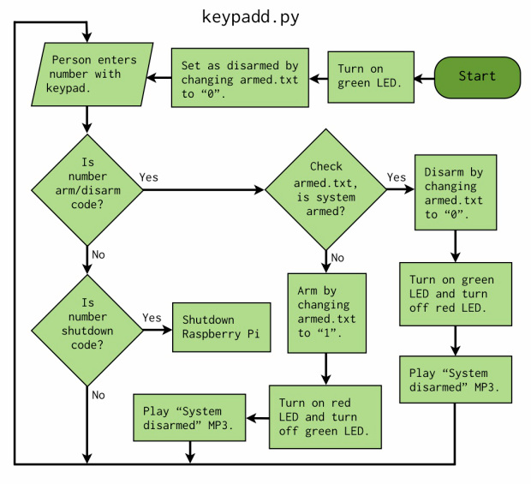

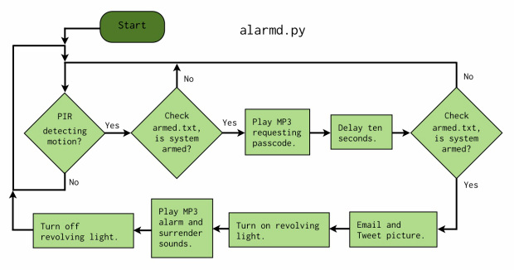

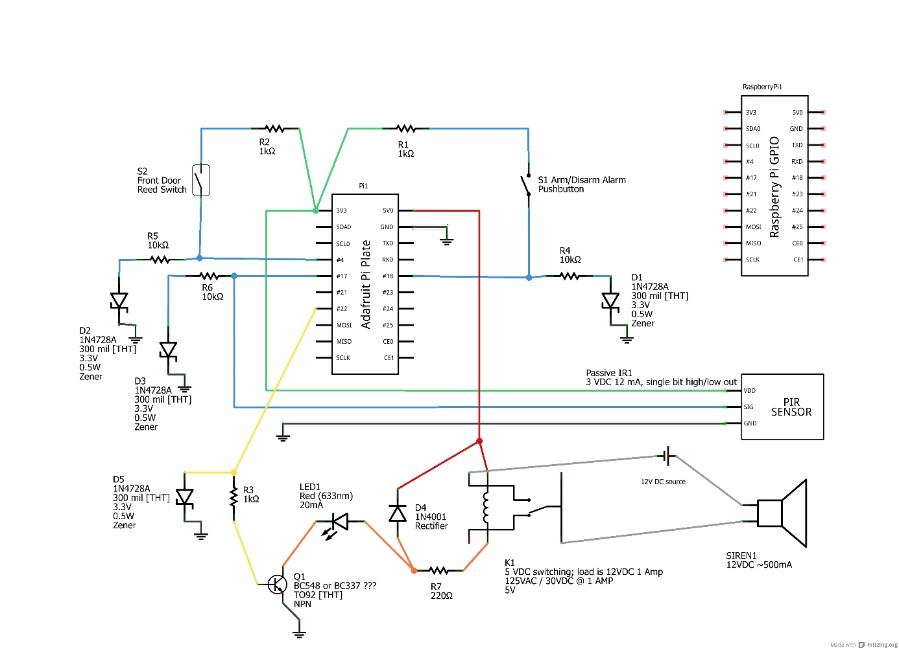
https://www.sugarsync.com/piv/D840799_380042_020807

HTML Page to Control the GPIOs
http://raspberrywebserver.com/gpio/piface/building-a-remote-control-vehicle-using-a-raspberry-pi.html
http://www.instructables.com/id/Simple-and-intuitive-web-interface-for-your-Raspbe/
http://www.pcduino.com/how-to-readcontrol-gpio-turn-onoff-led-on-web-page-using-python/
http://itechnofrance.wordpress.com/2013/02/04/piloter-les-ports-gpio-partir-dun-navigateur-internet/
Controlling GPIO Outputs Using a Web Interface
Webcontrol.py

http://www.paulschow.com/2013/06/raspberry-pi-internet-led-control.html
https://www.sparkfun.com/tutorials/337
http://electroniqueamateur.blogspot.fr/2014/03/controler-les-pins-gpio-du-raspberry-pi.html
http://plomteuxkevin.wordpress.com/2013/03/16/les-gpio/
****************SUPER**************
http://eduscol.education.fr/sti/sites/eduscol.education.fr.sti/files/ressources/pedagogiques/4346/4346-7-rpi-serveur-web.pdf
http://thefloppydisk.wordpress.com/2013/06/06/raspberry-pi-gpio-inputoutput-in-javascript/
https://github.com/ronanguilloux/php-gpio
http://webpy.org/src/

Sending email from python
import smtplib
GMAIL_USER = 'your_name@gmail.com'
GMAIL_PASS = 'your_password'
SMTP_SERVER = 'smtp.gmail.com'
SMTP_PORT = 587
def send_email(recipient, subject, text):
smtpserver = smtplib.SMTP(SMTP_SERVER, SMTP_PORT)
smtpserver.ehlo()
smtpserver.starttls()
smtpserver.ehlo
smtpserver.login(GMAIL_USER, GMAIL_PASS)
header = 'To:' + recipient + '\n' + 'From: ' + GMAIL_USER
header = header + '\n' + 'Subject:' + subject + '\n'
msg = header + '\n' + text + ' \n\n'
smtpserver.sendmail(GMAIL_USER, recipient, msg)
smtpserver.close()
send_email('destination_email_address', 'sub', 'this is text')

$ sudo apt-get install python-dev
$ sudo apt-get install python-rpi.gpio

Allume une LED:

import RPi.GPIO as GPIO
GPIO.setmode(GPIO.BCM)
GPIO.setup(18, GPIO.OUT)
GPIO.output(18, True)
GPIO.output(18, False)

Faire clignoter une LED
import RPi.GPIO as GPIO
import time
GPIO.setmode(GPIO.BCM)
GPIO.setup(18, GPIO.OUT)
while (True):
GPIO.output(18, True)
time.sleep(0.5)
GPIO.output(18, False)
time.sleep(0.5)

Contrôler un buzzer
import RPi.GPIO as GPIO
import time
buzzer_pin = 18
GPIO.setmode(GPIO.BCM)
GPIO.setup(buzzer_pin, GPIO.OUT)
def buzz(pitch, duration):
period = 1.0 / pitch
delay = period / 2
cycles = int(duration * pitch)
for i in range(cycles):
GPIO.output(buzzer_pin, True)
time.sleep(delay)
GPIO.output(buzzer_pin, False)
time.sleep(delay)
while True:
pitch_s = raw_input("Enter Pitch (200 to 2000): ")
pitch = float(pitch_s)
duration_s = raw_input("Enter Duration (seconds): ")
duration = float(duration_s)
buzz(pitch, duration)

Détecter un appui sur un bouton
import RPi.GPIO as GPIO
import time
GPIO.setmode(GPIO.BCM)
GPIO.setup(18, GPIO.IN, pull_up_down=GPIO.PUD_UP)
while True:
input_state = GPIO.input(18)
if input_state == False:
print('Button Pressed')
time.sleep(0.2)

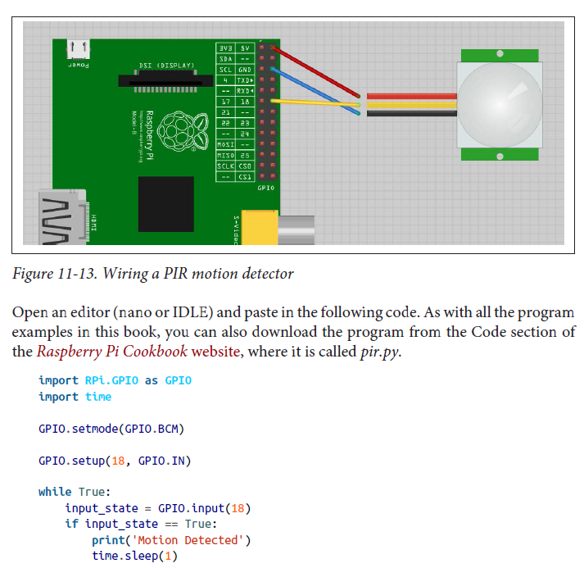

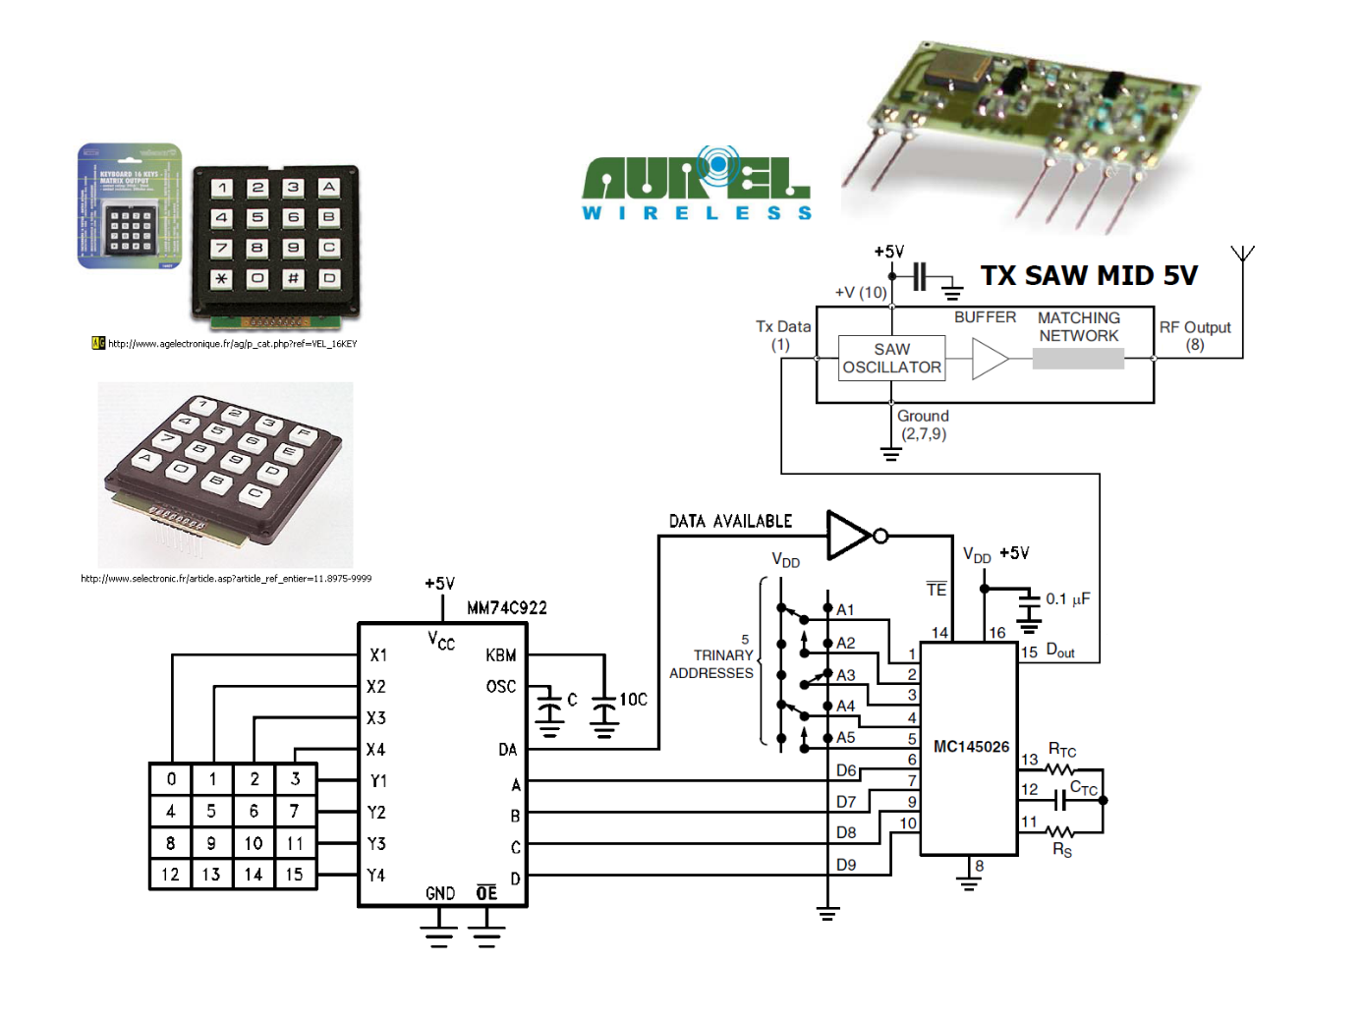
http://megasimple.free.fr/IMG/pdf/E_KEY.pdf
http://projets-electroniques.blogspot.fr/2012/09/une-serrure-electronique-cle-key.html
http://www.picaxe.com/Hardware/Project-Kits/iButton-Lock-Kit/
http://laboutiquededomotique.com/badges-et-controle-d-acces/409-dallas-ibutton-ds1990a-f5-avec-numero-de-serie-unique.html
DS1990A-F4, made by Dallas.
http://www.maximintegrated.com/en/products/ibutton/products/readers.cfm
http://kudelsko.free.fr/iboutton/presentation2.htm
http://shop.loxone.com/frfr/lecteur-cle-electronique.html
http://skyduino.wordpress.com/2012/03/17/arduino-tutoriel-1-wire-ds1994/
DS1990A

http://www.gotronic.fr/art-support-ds9092l-19208.htm
http://tushev.org/articles/arduino/item/50-reading-ibutton-with-arduino

Electronic Combination Lock using IC LS 7220

http://anderson69s.com/2013/04/20/afficheur-lcd-sur-raspberry-pi/
http://www.zem.fr/raspberry-pi-et-afficheur-lcd-hitachi-hd44780-1602-part-2/
http://www.projects.privateeyepi.com/home/on-off-project
https://learn.adafruit.com/drive-a-16x2-lcd-directly-with-a-raspberry-pi/wiring
http://www.themagpi.com/issue/issue-9/article/the-python-pit-drive-your-raspberry-pi-with-a-mobile-phone/
http://quaintproject.wordpress.com/2013/09/14/alert-mail-raspberry-pi/
https://gist.github.com/johnantoni/8199088

import RPi.GPIO as GPIO
import time

GPIO.setmode(GPIO.BCM)

pir_pin = 18 #le capteur PIR est connecté au GPIO 18
buzzer_pin = 22 #le buzzer est connecté au GPIO 22

GPIO.setup(pir_pin, GPIO.IN) #configuration en entrée pour le PIR
GPIO.setup(buzzer_pin, GPIO.OUT) #configuration en sortie pour le buzzer

Try:

while True:
if GPIO.input(pir_pin):
print("MOUVEMENT DETECTE!")
GPIO.output(buzzer_pin, True)
time.sleep(0.5)

except KeyboardInterrut:
GPIO.cleanup()

http://intelligenceonline.synergize.co/news/detecter-les-entrees-et-les-sorties

http://blog.idleman.fr/raspberry-pi-13-detecter-louverture-des-portes-et-fenetres/
http://oversimple.fr/halloween-tricks/

