Configuration du raspberry

http://mchobby.be/wiki/index.php?title=Rasp-Os-Whezzy

Switch a light on/off using your smart phone

http://www.instructables.com/id/Raspberry-Pi-GPIO-home-automation/

web2py

https://coderwall.com/p/jsd5mw

https://code.google.com/p/webiopi/

import RPi.GPIO as GPIO
import time
GPIO.setmode(GPIO.BCM)
PIR_PIN = 7
GPIO.setup(PIR_PIN, GPIO.IN)
def MOTION(PIR_PIN):
print “Motion Detected!”
print “PIR Module Test (CTRL+C to exit)”
time.sleep(2)
print “Ready”
try:
GPIO.add_event_detect(PIR_PIN, GPIO.RISING, callback=MOTION)
while 1:
time.sleep(100)
except KeyboardInterrupt:
print “ Quit”
GPIO.cleanup()

GPIO polling

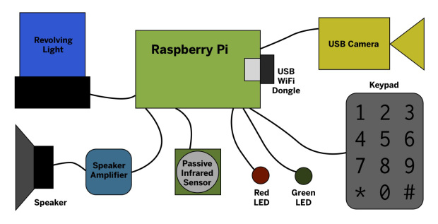
http://makezine.com/projects/pilarm-portable-raspberry-pi-room-alarm/
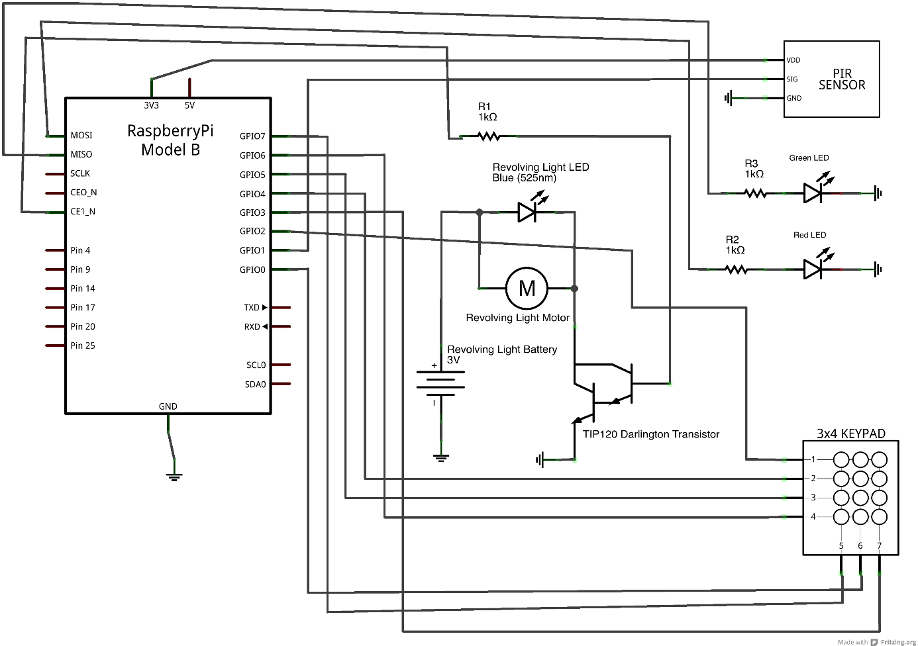

http://easyeda.com/
http://arduino103.blogspot.fr/2014_07_01_archive.html
GPIO17 11
GPIO18 12
GPIO27 13
GPIO22 15
GPIO23 16
GPIO24 18
GPIO25 22

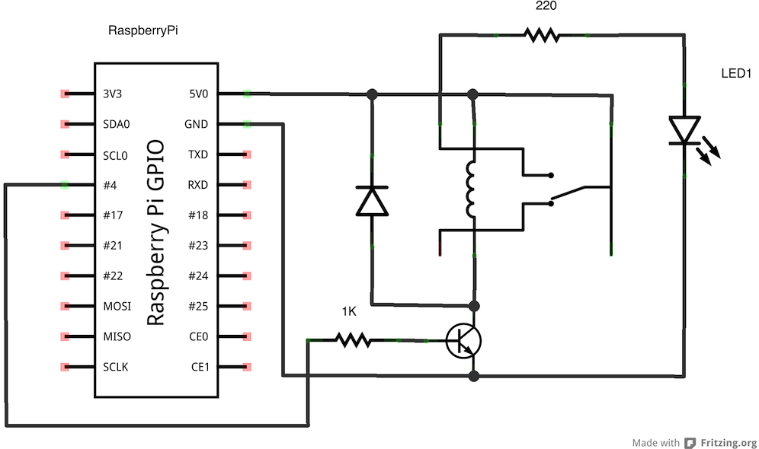
Omron G5LA-1 5DC can switch loads of 10A at 240V.

single pole single throw (SPST)
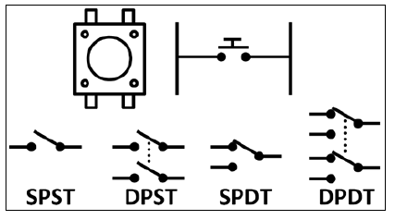

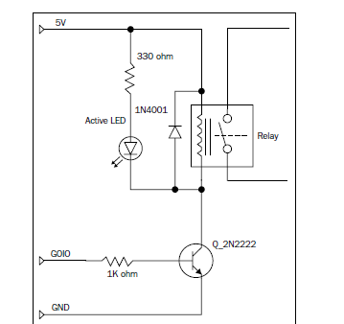
GPIO.add_event_detect
pull_up_down

import RPi.GPIO as GPIO
#set up GPIO using BCM numbering
GPIO.setmode(GPIO.BCM)
#setup GPIO using Board numbering
GPIO.setmode(GPIO.BOARD)
GPIO.setup(23, GPIO.IN, pull_up_down=GPIO.PUD_DOWN)
GPIO.setup(24, GPIO.IN, pull_up_down=GPIO.PUD_UP)

import RPi.GPIO as GPIO
GPIO.setmode(GPIO.BCM)
GPIO.setup(23, GPIO.IN, pull_up_down = GPIO.PUD_DOWN)
GPIO.setup(24, GPIO.IN, pull_up_down = GPIO.PUD_UP)
while True:
if(GPIO.input(23) ==1):
print(“Button 1 pressed”)
if(GPIO.input(24) == 0):
print(“Button 2 pressed”)
GPIO.cleanup()

import RPi.GPIO as GPIO
GPIO.setmode(GPIO.BCM)
GPIO.setup(23, GPIO.IN, pull_up_down = GPIO.PUD_DOWN)
GPIO.setup(24, GPIO.IN, pull_up_down = GPIO.PUD_UP)
while True:
GPIO.wait_for_edge(23, GPIO.RISING)
print(“Button 1 Pressed”)
GPIO.wait_for_edge(23, GPIO.FALLING)
print(“Button 1 Released”)
GPIO.wait_for_edge(24, GPIO.FALLING)
print(“Button 2 Pressed”)
GPIO.wait_for_edge(24, GPIO.RISING)
print(“Button 2 Released”)
GPIO.cleanup()

import RPi.GPIO as GPIO
GPIO.setmode(GPIO.BCM)
GPIO.setup(23, GPIO.IN, pull_up_down = GPIO.PUD_DOWN)
GPIO.setup(24, GPIO.IN, pull_up_down = GPIO.PUD_UP)
def printFunction(channel):
print(“Button 1 pressed!”)
print(“Note how the bouncetime affects the button press”)
GPIO.add_event_detect(23, GPIO.RISING, callback=printFunction, bouncetime=300)
while True:
GPIO.wait_for_edge(24, GPIO.FALLING)
print(“Button 2 Pressed”)
GPIO.wait_for_edge(24, GPIO.RISING)
print(“Button 2 Released”)
GPIO.cleanup()

GPIO.remove_event_detect(23)

http://raspi.tv/2013/rpi-gpio-basics-6-using-inputs-and-outputs-together-with-rpi-gpio-pull-ups-and-pull-downs
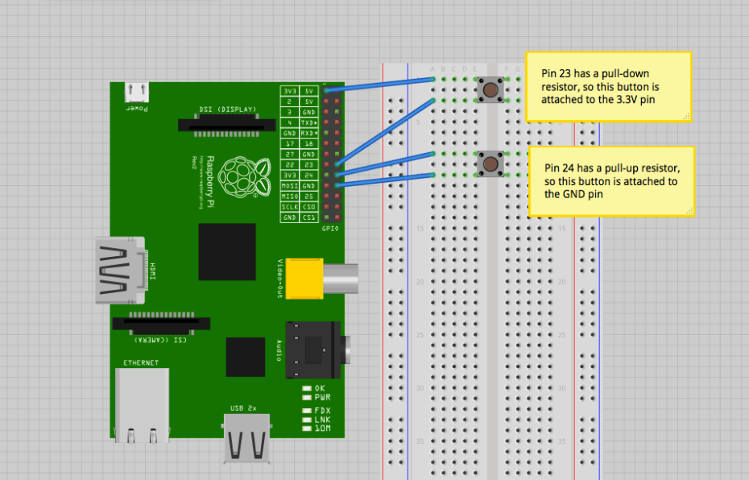

pull-up/Pull-down interne
Pour les initiés, votre Raspberry-Pi dispose déjà de résistance pull-up ou pull-down que vous pouvez activer au moment de la déclaration de la broche en entrée.
GPIO.setup(23, GPIO.IN, pull_up_down=GPIO.PUD_DOWN)
GPIO.setup(24, GPIO.IN, pull_up_down=GPIO.PUD_UP)

Anti rebont
http://mchobby.be/wiki/index.php?title=Rasp-Hack-PiButton

import RPi.GPIO as GPIO, time

GPIO.setmode(GPIO.BCM)
GREEN_LED = 18
RED_LED = 23

BUTTON1 = 24
# Dernier état connu du bouton
# Par defaut: le bouton n'est pas considéré comme activé
BUTTON1_STATE = False

GPIO.setup(GREEN_LED, GPIO.OUT)
GPIO.setup(RED_LED, GPIO.OUT)
GPIO.setup(BUTTON1, GPIO.IN)

while True:
# -- Lecture avec déparasitage logiciel
# Si le bouton est pressé, la broche GPIO est raccordée
# à la masse. Le GPIO est donc à LOW (bas).
# Bouton pressé -> Input = LOW = False
gpioRead1 = GPIO.input( BUTTON1 )
state1 = not(gpioRead1)
# SI changer d'etat ALORS refaire lecture de déparasitage
if( state1 != BUTTON1_STATE ):
# - attendre 10ms
time.sleep( 10 / 1000 )
# faire une 2ieme lecture
gpioRead2 = GPIO.input( BUTTON1 )
state2 = not(gpioRead2)
# SI les deux lectures concordent
# ALORS memoriser le nouvel etat du bouton
if( state1 == state2 ):
BUTTON1_STATE = state2

# -- Programme principal --
# SI le bouton est pressé
# ALORS allumer la LED verte
if( BUTTON1_STATE == True ):
GPIO.output(GREEN_LED, False)
GPIO.output(RED_LED, True)
else:
GPIO.output(GREEN_LED, True)
GPIO.output(RED_LED, False)

http://www.pervasive-network.org/2009/05/encadrement-annotation-et-tags-iptc-de-photo-en-ligne-de-commande-avec-convert-imagemagick-et-exiftool/

#!/bin/bash

DATE=$(date +"%Y-%m-%d_%H%M")

raspistill -vf -hf -o /home/pi/camera/$DATE.jpg

raspistill -o image.jpg // capture d'une image en jpeg

#!/usr/bin/env python
import time
import RPi.GPIO as GPIO

# Use GPIO numbering
GPIO.setmode(GPIO.BCM)

# Set GPIO for camera LED
CAMLED = 5

# Set GPIO to output
GPIO.setup(CAMLED, GPIO.OUT, initial=False)

# Five iterations with half a second
# between on and off
for i in range(5):
GPIO.output(CAMLED,True) # On
time.sleep(0.5)
GPIO.output(CAMLED,False) # Off
time.sleep(0.5)

To disable the red LED you simply need to add the following line to your config.txt file :
disable_camera_led=1
To edit the config.txt file you can use Nano :
sudo nano /boot/config.txt

sudo nano /boot/config.txt
# ajouter la ligne suivante :
disable_camera_led=1
# rebooter
sudo reboot

#!/bin/bash
TMP='/tmp'
OUTPUT_FILE='webcam.jpg'
OPTIONS='-w 800 -h 600 -q 80'
cd $TMP
raspistill -o $OUTPUT_FILE $OPTIONS
/usr/local/bin/send-ftp $OUTPUT_FILE

