Role of testing
Test
A manufacturing step that ensures that the physical
device, manufactured from the synthesized design,
has no manufacturing defect

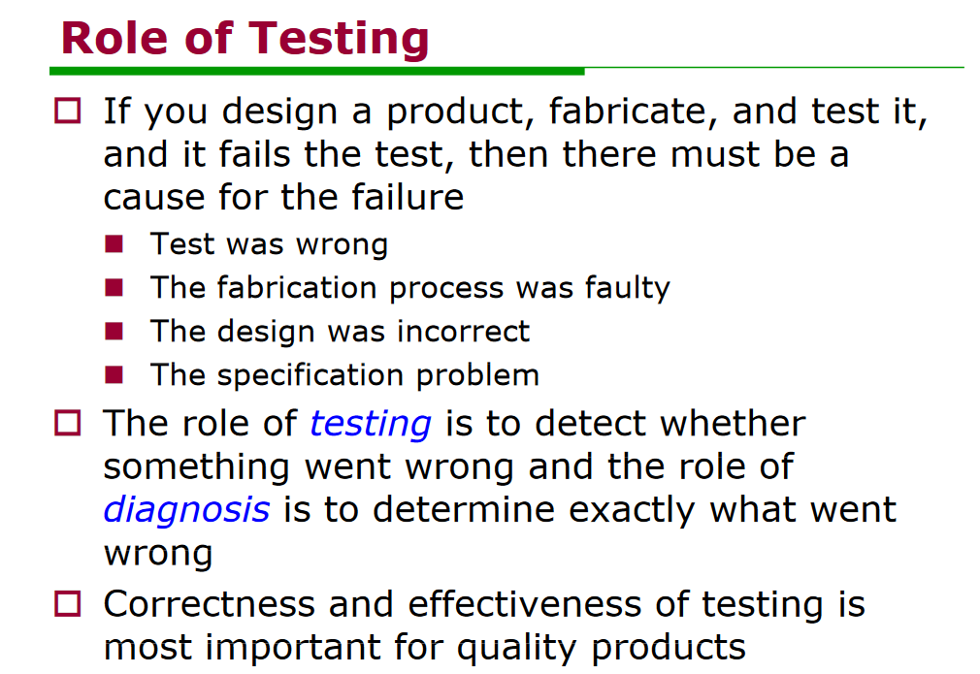

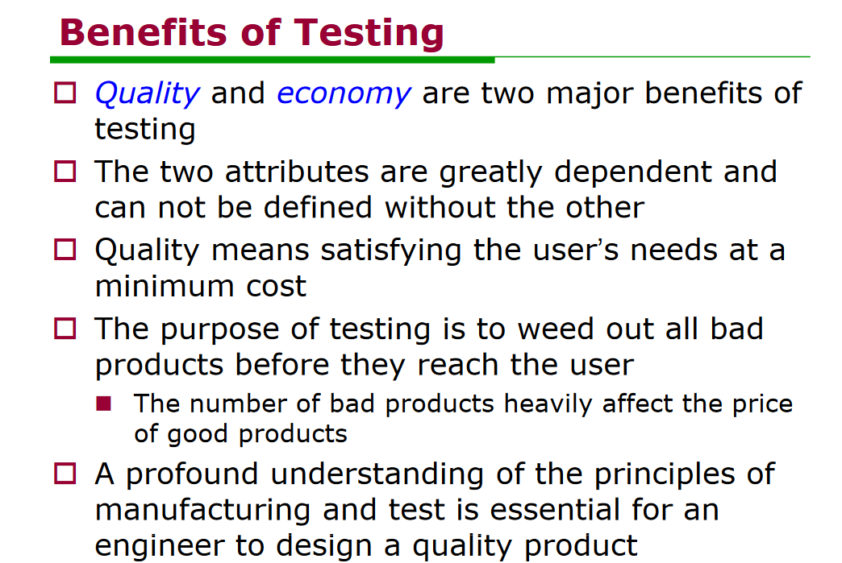
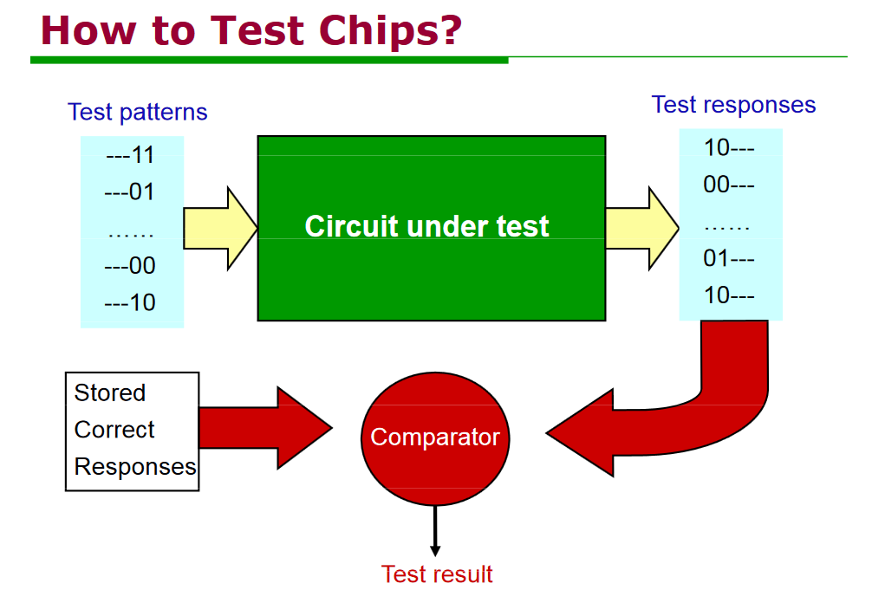

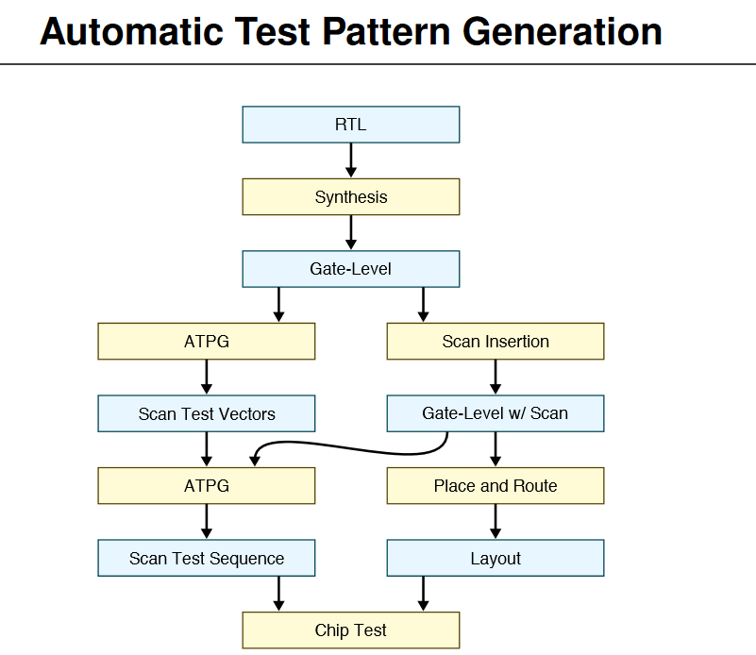

Encounter DFT flow :
add testability logic
synthetize and map to scan
https://support.cadence.com/apex/ArticleAttachmentPortal?id=a1Od000000050PjEAI&pageName=ArticleContent&sq=005d0000005nO87AAE_201852214355809
wrapper
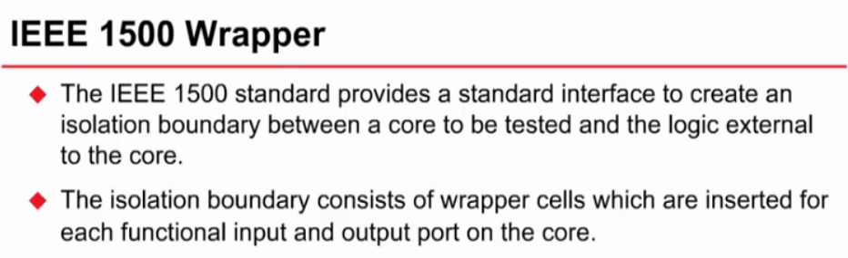
https://support.cadence.com/apex/ArticleAttachmentPortal?id=a1Od0000000510DEAQ&pageName=ArticleContent&oMenu=People%20who%20viewed%20this%20also%20viewed
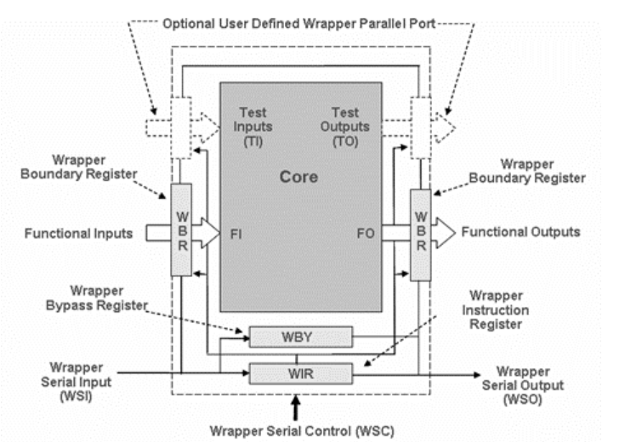

http://www.groupes.polymtl.ca/ele6306/pages/cours.php

wrapper’s task:
interface between core and rest of chip
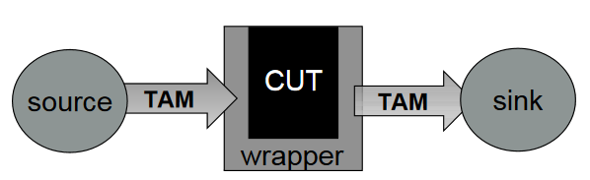
http://www.ee.ncu.edu.tw/~jfli/vlsidi/lecture/dft

