Clocks

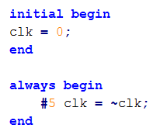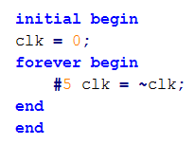

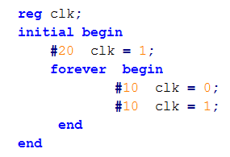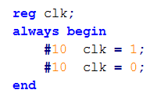

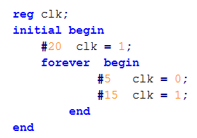

@(posedge clk) says « wait for a trigger »

What are blocks ?
Block statements are used to group multiple statements to act together as one.

In previous examples we used keywords begin and end to group multiple statements.
Thus, we used sequential blocks where the statements in the block execute one after another.
In this section we discuss the block types: sequential blocks and parallel blocks

Sequential blocks

The keywords begin and end are used to group statements into sequential blocks.

Sequential blocks have the following characteristics:
The statements in a sequential block are processed in the order they are specified. A statement is executed only after its preceding statement completes execution
(except for nonblocking assignments with intra-assignment timing control).
If delay or event control is specified, it is relative to the simulation time when the previous statement in the block completed execution.

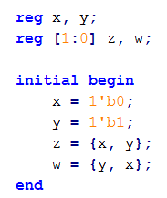

The final values are x = 0, y= 1, z = 1, w = 2 at simulation time 0.

Sequential blocks with delay

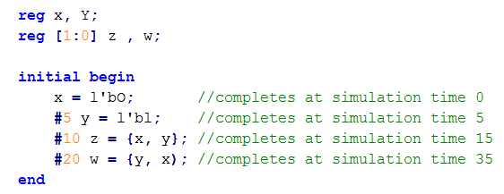

Parallel blocks, specified by keywords fork and join, provide interesting simulation features.
Parallel blocks have the following characteristics.

- Statements in a parallel block are executed concurrently.
- Ordering of statements is controlled by the delay or event control assigned to each statement.
- If delay or event control is specified, it is relative to the time the block was entered

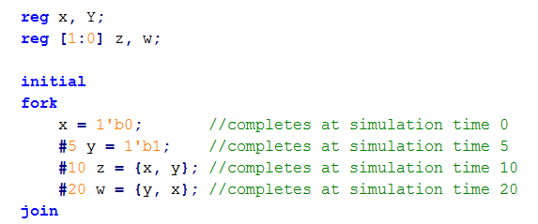
NOTE : The result of simulation remains the same except that all statements start in parallel at time 0. Hence, the block finishes at time 20 instead of time 35

Disabling a block
The keyword
disable
provides a way to terminate the
execution of a block.
♦
disable can be used to get out of loops, handle error
conditions, or control execution of pieces of code, based on
a control signal.
♦
Disabling a block causes the execution control to be passed
to the statement immediately succeeding the block.
♦
For C programmers, this is very similar to the break
statement used to exit a loop. The difference is that a break
statement can break the current loop only, whereas the
keyword disable allows disabling of any named block in the
design

/*****************************************************************/

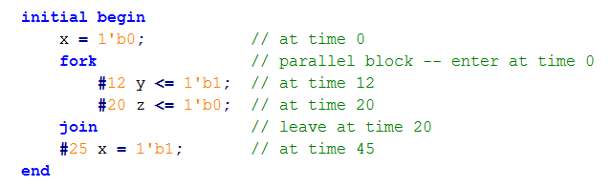

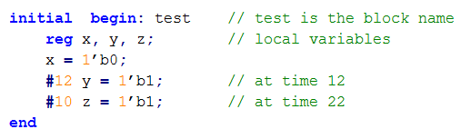

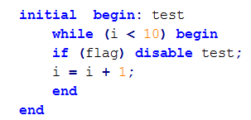

join
fork
execute
monitor
initialize

