http://www.academia.edu/5272241/The_ECE_218_Analog_VLSI_Circuit_Design_CMOS_Operational_Amplifier
http://iasir.net/IJETCASpapers/IJETCAS13-335.pdf
http://www.aicdesign.org/SCNOTES/2010notes/Lect2UP250_%28100328%29.pdf
AMI C5N 0.6 µm
http://www.joace.org/uploadfile/2014/0310/20140310043126523.pdf
http://www.groupes.polymtl.ca/gbm8320/CADENCE_Manual.pdf
http://docslide.us/documents/cmos-opamp-low-power-2012.html

The gm/ID Methodology, a sizing tool for low-voltage analog CMOS Circuits

Nano-CMOS Circuit and Physical Design

Par Ban Wong,Anurag Mittal,Yu Cao,Greg W. Starr

Design of CMOS Operational Amplifiers (Artech House Microwave Library)

Rasoul Dehghani Author
https://books.google.fr/books?id=QRf0o477nBsC&pg=PA56&lpg=PA56&dq=cmos+op+amp+systematic+offset&source=bl&ots=aEWkM6LYWA&sig=QpEnr5AeJpi_XE1T2FgoCK4xYw8&hl=fr&sa=X&ei=PGJYVYnECouAU6v_gKAL&ved=0CCAQ6AEwADgK#v=onepage&q=cmos%20op%20amp%20systematic%20offset&f=false
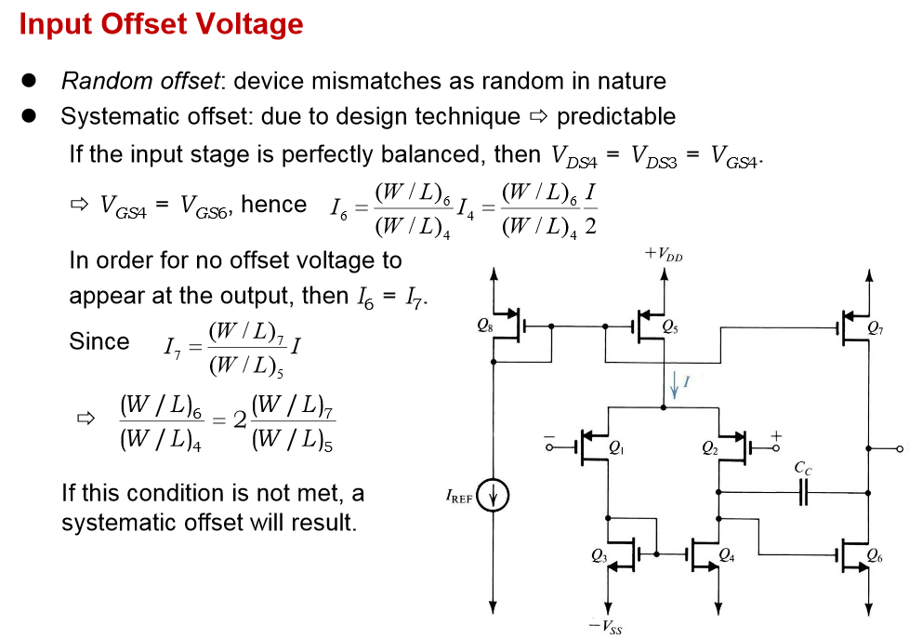
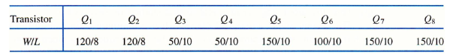

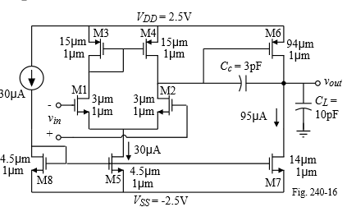

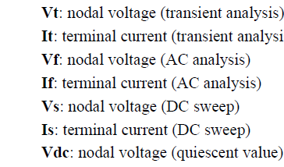

CMOS Differential Amplifiers
Page 257 to page 259,Ken Martin's book:
for the wide-swing cascode current mirror,the L of the bottom transistors are less than the top.
I have seen some design circuits, the L of the bottom transistors are larger than that of the top transistors.
I get confused.

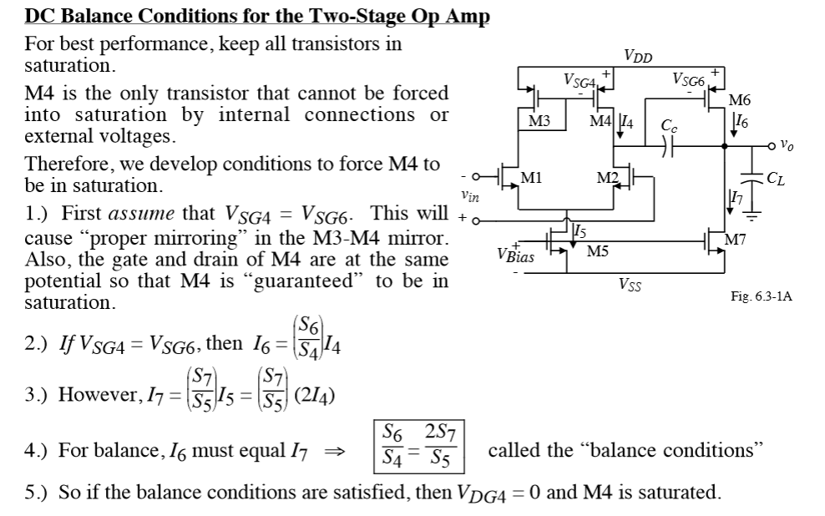

from the model file, for nominal process corner, the specified values are as follows
parameter NMOS PMOS
tox 1.39e-8m 1.39e-8m
Cox(from tox) 2.484e-3F/m^2 2.484e-3F/m^2
un 458.43e-4m^2/Vs 212.02e-4m^2/Vs
Kn/Kp(=uncox) 113.88uA/V^2 52.66uA/V^2

You can also extract these parameters by running simulations.
You can find a very good approach in. They guide you through the process of extracting device parameters via measurements or simulation.

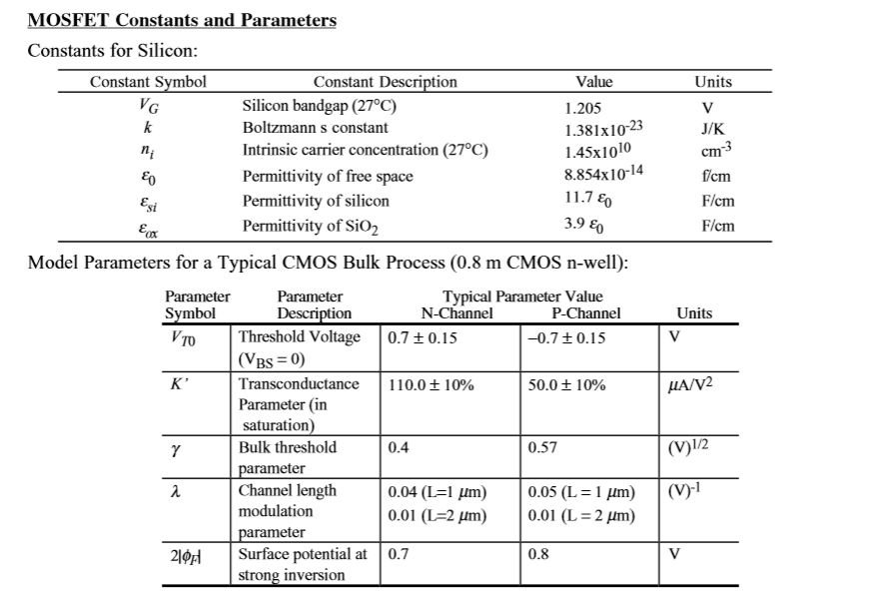

Miroir de courant simple
Voici les paramétres qui influent sur la précision
- Channel length modulation (λ)
- Threshold offset
- Parasitic resistances
- Imperfect geometrical matching and current mobility variation

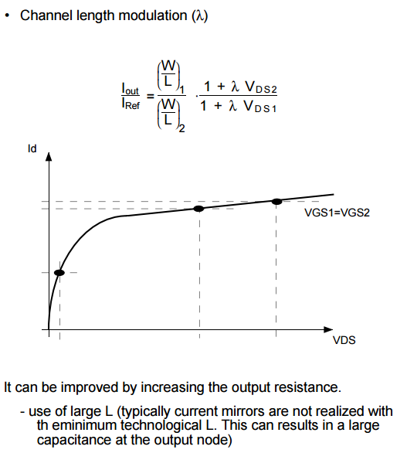

Gain en courant
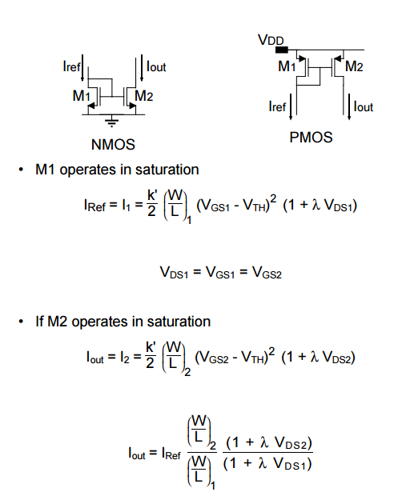
donc le matching entre M1 et M2 est mauvais
Miroir de courant cascoded
donc la recopie est précise
Factors affecting the mirror accuracy
Channel length modulation (λ)

Use of long device (large L) to increase rout
Use of large (VGS – VTH) for good matching (small importance of VTH mismatch)
use of large L (typically current mirrors are not realized with th eminimum technological L. This can results in a large capacitance at the output node)
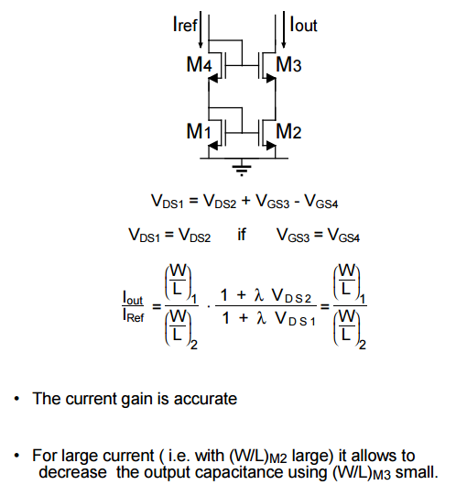
VDS1 = VGS3 –VGS4+VDS2 =VDS2

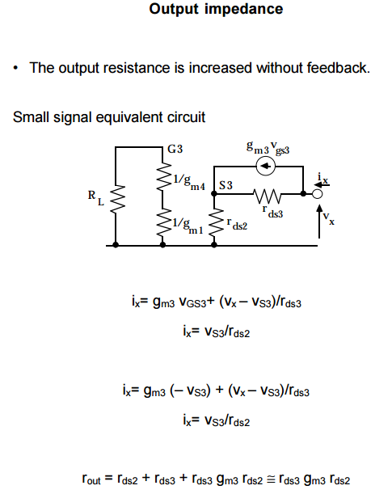

Wide Swing Cascode Current Mirror

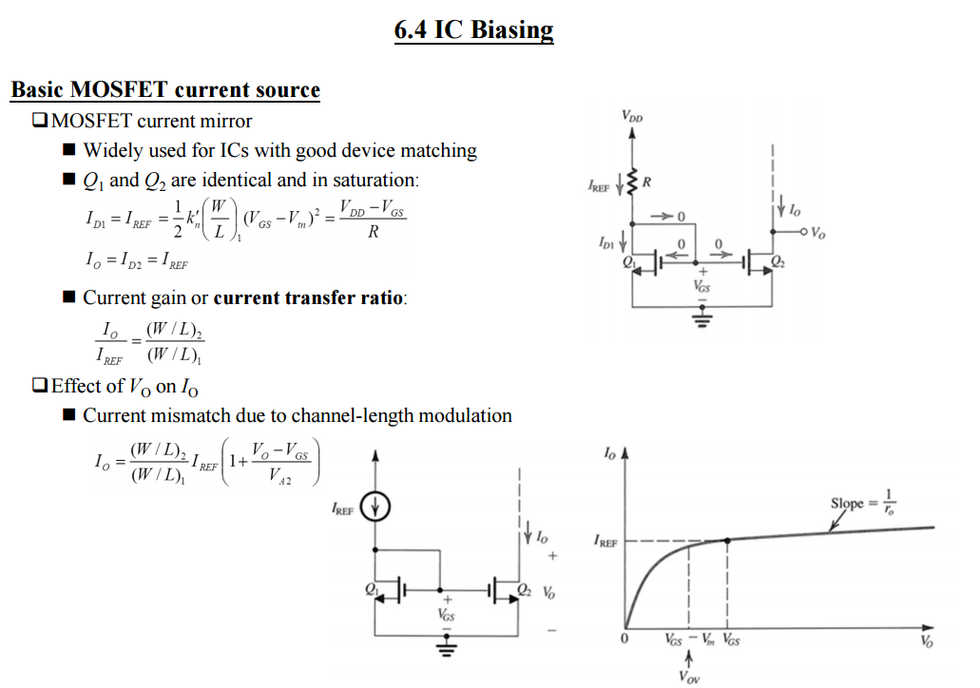

Tradeoffs and Optimization in Analog CMOS Design
Par David Binkley

cmos differential amplifier analysis
current mirror channel length modulation
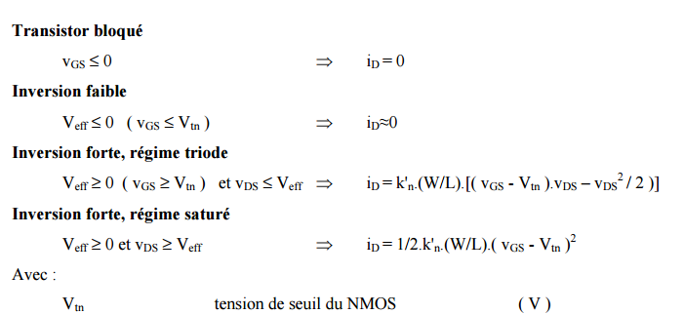

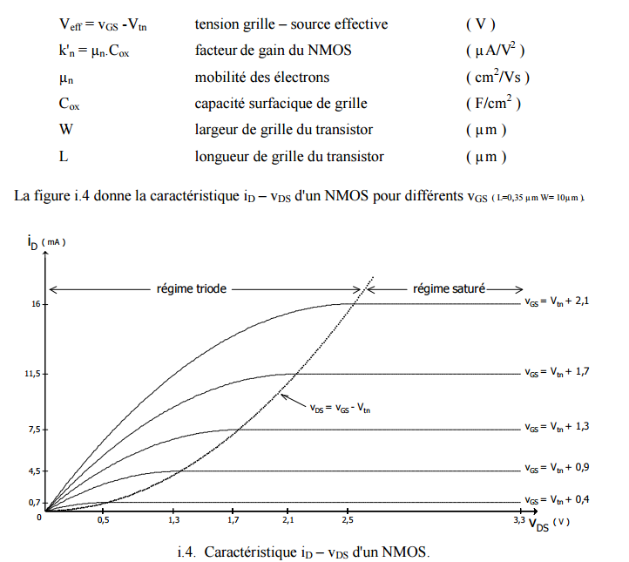
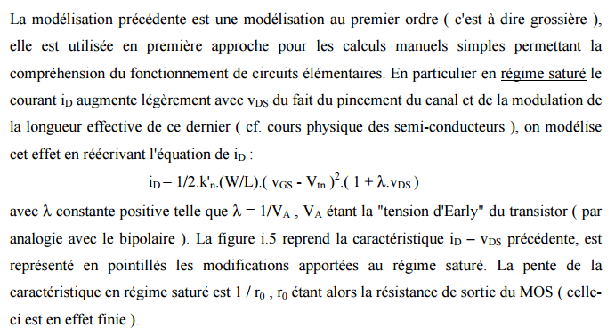
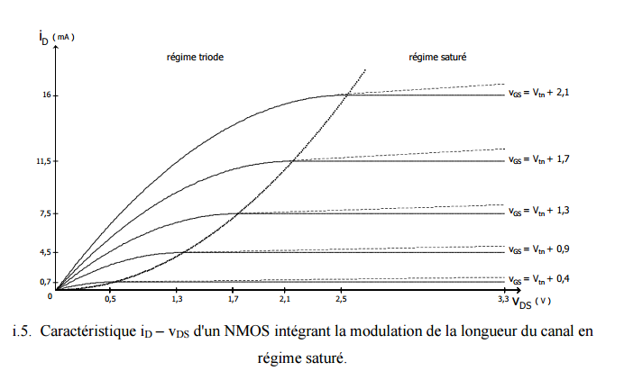
http://www.mines-stetienne.fr/~dutertre/documents/1_cours_diode_final_web.pdf
modulation de la largeur du canal

