Woocommerce
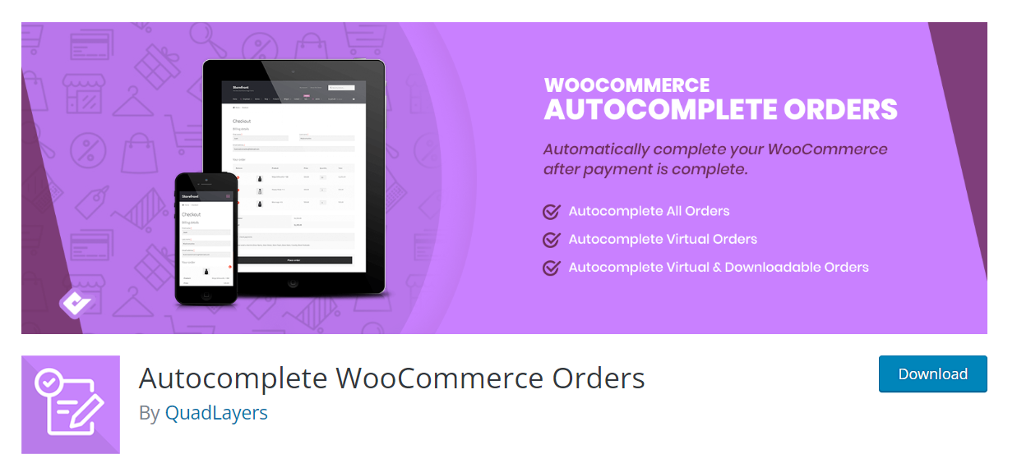

https://wpmarmite.com/factures-woocommerce/

https://www.youtube.com/watch?v=U5aIjRJrL08 email template customized
https://cleanup.pictures/
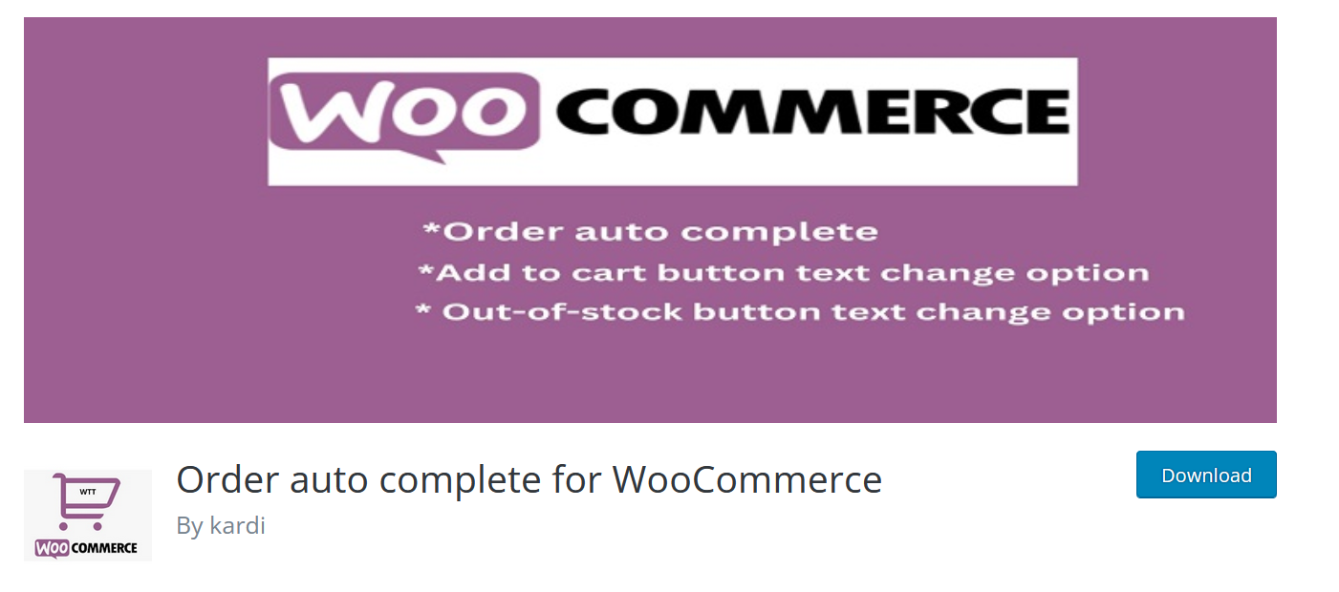

add_filter( ‘woocommerce_payment_complete_order_status’, ‘auto_complete_virtual_orders’, 10, 3 );
function auto_complete_virtual_orders( $payment_complete_status, $order_id, $order ) {
$current_status = $order->get_status();
// We only want to update the status to ‘completed’ if it’s coming from one of the following statuses:
$allowed_current_statuses = array( ‘on-hold’, ‘pending’, ‘failed’ );
if ( ‘processing’ === $payment_complete_status && in_array( $current_status, $allowed_current_statuses ) ) {
$order_items = $order->get_items();
// Create an array of products in the order
$order_products = array_filter( array_map( function( $item ) {
// Get associated product for each line item
return $item->get_product();
}, $order_items ), function( $product ) {
// Remove non-products
return !! $product;
} );
if ( count( $order_products > 0 ) ) {
// Check if each product is ‘virtual’
$is_virtual_order = array_reduce( $order_products, function( $virtual_order_so_far, $product ) {
return $virtual_order_so_far && $product->is_virtual();
}, true );
if ( $is_virtual_order ) {
$payment_complete_status = ‘completed’;
}
}
}
return $payment_complete_status;
}

The final code will look something like this.

add_action( 'woocommerce_thankyou', 'auto_complete_woocommerce_order' );
function auto_complete_woocommerce_order( $order_id ) {
if ( ! $order_id ) {
return;
}

$order = wc_get_order( $order_id );
$order->update_status( 'completed' );

https://www.youtube.com/watch?v=3DdSwB2-0Js pays de l’est …

https://www.youtube.com/watch?v=ACelC554-fU enzo, plugin merchant
productX ???
Ajax search pro
Yellow pencil
Mailster
https://www.phlox.pro/go/ thémes
duplicate pro
Element pack
Seedprod
Essential addons for elementor
Wp user frontend
Ultimate addon pro
Unlimited elements
complianz-gdpr-premium
facetWP search
Elements kit
Happy elementor addon
Elementor extras

Cartflows pro
WP file manager
Forminator
Smart slider 3 pro
Powerpack addon for elementor

MailPoet
User registration
Profile builder
WP Content Copy Protection
Codesigner pro ????
Elements kits
Wpfunnel
https://www.wpxpo.com/productx/
Premium addons pro
https://underconstructionpage.com/
https://shopmagic.app/product-category/add-ons/

formidable forms
the plus addons for elementor

cartflows + spectra

advanced coupons
smart coupons webtoffee

wc-smart-coupons endpoint ???

