Query google :

analog layout floorplan

//////////////////////////////////////////////////////////

Rule of thumb

Analog floorplan
Creating the right floorplan for these chips is a critical task that must evolve and be refined as the project progresses.
The shape and size of analog blocks are dictated by the performance requirements of the block like the need for device matching and layout dependent effect (LDE) considerations.

The floorplanning task starts almost as soon as work on the project is begun. The floorplan designer takes early circuit information and uses that to create the initial floorplan. It’s usually done long before the layout of any functional block is available and the designer relies on accurate estimations of block area and size. Getting accurate size estimations for analog blocks is critical to being able to create an initial floorplan because of the knock-on effect they have on the size and shape of many of the other blocks on the chip.

https://www.planetanalog.com/rule-of-thumb-or-layout-automation-for-analog-floorplan/
https://athena.ecs.csus.edu/~pheedley/analog_methodology.pdf

Analog design & layout is an iterative process! (e.g., layout “tweaks” are typically required after sims with extracted parasitics)


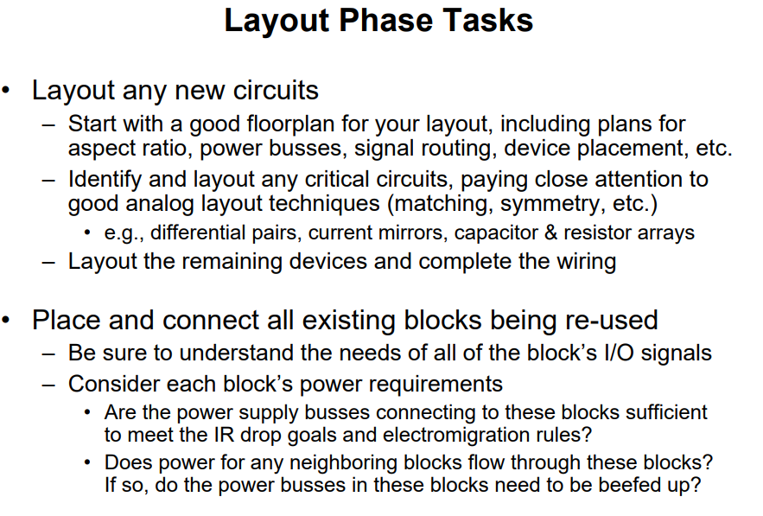

https://athena.ecs.csus.edu/~pheedley/analog_methodology.pdf

https://people.eecs.berkeley.edu/~boser/courses/240B/lectures/M14%20Layout.pdf

Floorplanning is the art of any physical design. A well and perfect floorplan leads to an ASIC design with higher performance and optimum area.
Floorplanning can be challenging in that, it deals with the placement of I/O pads and macros as well as power and ground structure.
Before we are going for the floor planning to make sure that inputs are used for floorplan is prepared properly.

- Floorplan, integrate, estimate area and create abstract views
- Place and route on block, top and full chip level in Cadence environment
- Work on I/O and ESD blocks as well as PAD and seal ring
- Work on physical layout verification (DRC, LVS, ERC and other) and debug
- Perform parasitic and EM extractions and work closely with Design Engineers and other IC Layout Engineers

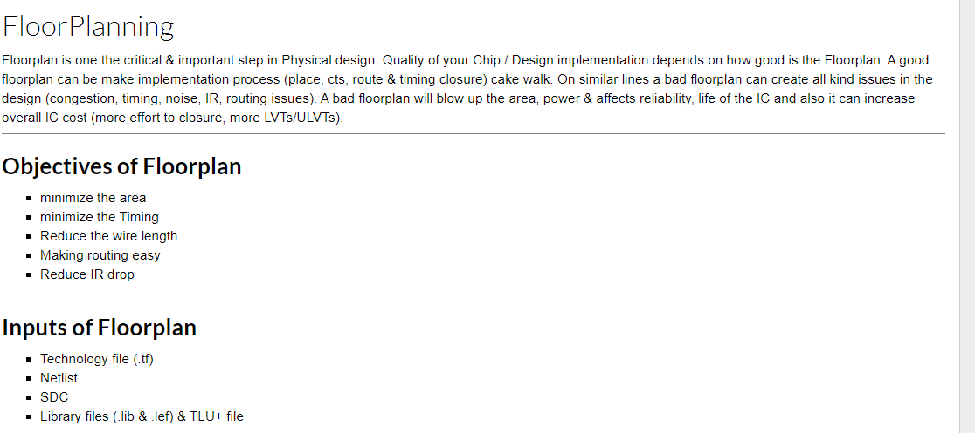
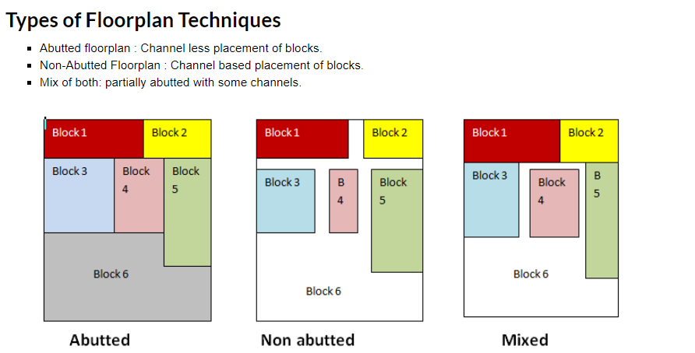

https://www.eng.auburn.edu/~nelson/courses/elec5250_6250/slides/ASIC%20Layout_3%20Chip%20Level.pdf

layout analog IC design
discussion
the step of layout design, where a circuit schematic is to be turned into a physical circuit implementation represents a severely time-consuming bottleneck in the overall design flow

Levels of Design Hierarchy

State of the art
Top down / bottom up
Constraints drive floorplan
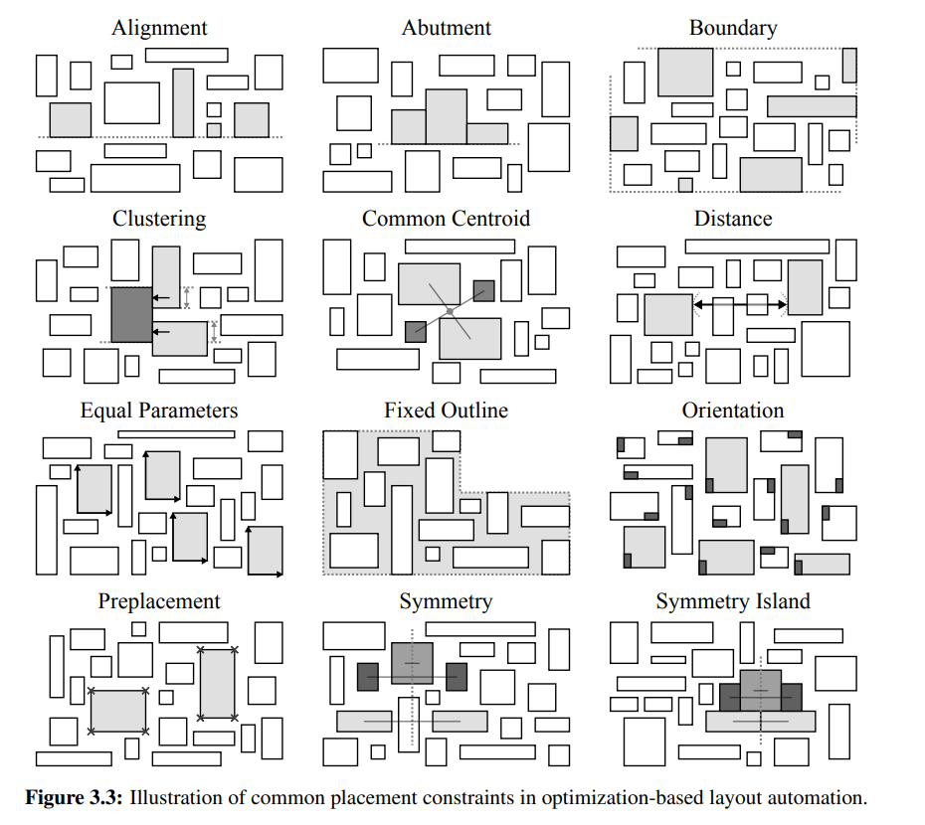
Assessment Criteria for a Layout Methodology in the Analog Domain

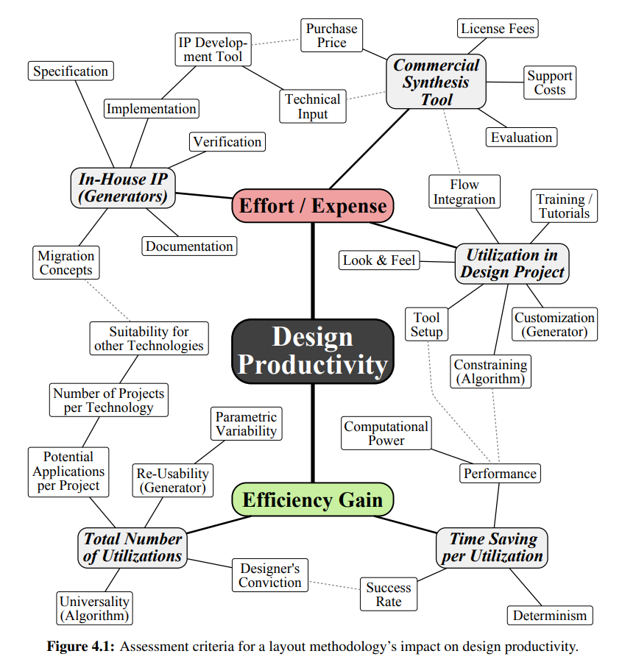

Layout quality
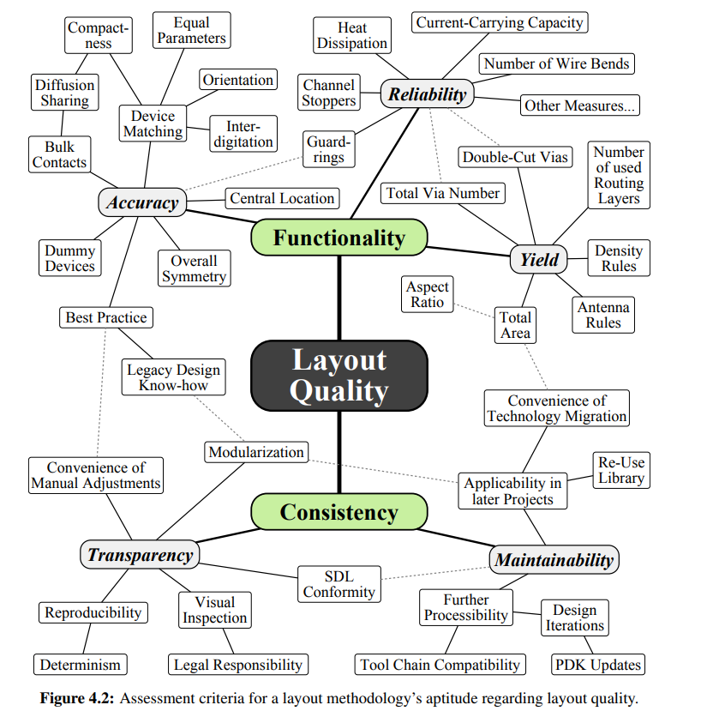

Reliability & yield

Constraint-Based Layout-Driven Sizing of Analog Circuits

http://cc.ee.ntu.edu.tw/~ywchang/Courses/PD_Source/EDA_floorplanning.pdf

Floorplanning is an essential design step for hierarchical, building-module design methodology. Floorplanning provides early feedback that evaluates architectural decisions, estimates chip areas, and estimates delay and congestion caused by wiring. As technology advances, design complexity is increasing and the circuit size is getting larger. To cope with the increasing design complexity, hierarchical design and intellectual property (IP) modules are widely used. This trend makes floorplanning much more critical to the quality of a very large-scale integration (VLSI) design than ever.

Including both analog and digital blocks
https://sipi.usc.edu/reports/pdfs/Scanned/USC-SIPI-189.pdf chapitre 5 +++
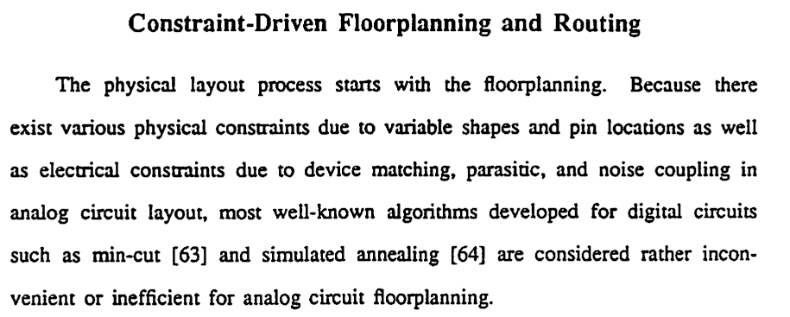

https://research.library.mun.ca/13002/1/thesis.pdf
Competitive consumer electronics demands high-end technologies

analog integrated circuits floorplanning pdf
https://picture.iczhiku.com/resource/eetop/WYifpKLGePewlxNX.pdf

Design partitionning

constraints drive layout floorplan

https://en.wikipedia.org/wiki/Floorplan_(microelectronics)

https://www.ifte.de/mitarbeiter/lienig/analogBook_chapter_7_pp271.pdf

https://mixsignal.files.wordpress.com/2013/03/analog-layout.pdf

http://smdpc2sd.gov.in/downloads/IGF/IGF%201/Introduction%20to%20Analog%20Layout%20Design.pdf

https://people.engr.tamu.edu/spalermo/ecen474/lecture05_ee474_layout.pdf
power distribution IR drop
electromigration current flows naroow wires, metal begins to migrate
- As current flows down narrow wires, metal begins to migrate
- Metal lines break over time due to metal fatigue
- Based on average/peak current density
- Need to widen wires enough to avoid this phenomenon

Making a Decoupling Cap

