Clock.v

module clock_gen (clock);
parameter Half_cycle = 50;
output clock;
reg clock;

initial
clock = 0;

always
begin
# Half_cycle clock = ~ clock;
end
endmodule

//////////////////////////////////////////////////////////////////////////////////////////////
Encodeur.v

module encoder (Code, Data);
output [2: 0] Code;
input [7: 0] Data;
reg [2: 0] Code;

always @ (Data)
begin
if (Data == 8'b00000001) Code = 0; else
if (Data == 8'b00000010) Code = 1; else
if (Data == 8'b00000100) Code = 2; else
if (Data == 8'b00001000) Code = 3; else
if (Data == 8'b00010000) Code = 4; else
if (Data == 8'b00100000) Code = 5; else
if (Data == 8'b01000000) Code = 6; else
if (Data == 8'b10000000) Code = 7; else Code = 3'bx;
end

/* Alternative description is given below

always @ (Data)
case (Data)
8'b00000001 : Code = 0;
8'b00000010 : Code = 1;
8'b00000100 : Code = 2;
8'b00001000 : Code = 3;
8'b00010000 : Code = 4;
8'b00100000 : Code = 5;
8'b01000000 : Code = 6;
8'b10000000 : Code = 7;
default : Code = 3'bx;
endcase
*/
endmodule

//////////////////////////////////////////////////////////////////

decodeur

module decoder (Data, Code);
output [7: 0] Data;
input [2: 0] Code;
reg [7: 0] Data;

always @ (Code)
begin
if (Code == 0) Data = 8'b00000001; else
if (Code == 1) Data = 8'b00000010; else
if (Code == 2) Data = 8'b00000100; else
if (Code == 3) Data = 8'b00001000; else
if (Code == 4) Data = 8'b00010000; else
if (Code == 5) Data = 8'b00100000; else
if (Code == 6) Data = 8'b01000000; else
if (Code == 7) Data = 8'b10000000; else
Data = 8'bx;
end
/* Alternative description is given below
always @ (Code)
case (Code)
0 : Data = 8'b00000001;
1 : Data = 8'b00000010;
2 : Data = 8'b00000100;
3 : Data = 8'b00001000;
4 : Data = 8'b00010000;
5 : Data = 8'b00100000;
6 : Data = 8'b01000000;
7 : Data = 8'b10000000;
default : Data = 8'bx;
endcase
*/
endmodule

//////////////////////////////////////////////////////////////////////////////////////////////
Register à décalage

module Shift_reg4 (Data_out, Data_in, clock, reset);
output Data_out;
input Data_in, clock, reset;
reg [3: 0] Data_reg;

assign Data_out = Data_reg[0];

always @ (negedge reset or posedge clock)
begin
if (reset == 1'b0) Data_reg <= 4'b0;
else Data_reg <= {Data_in, Data_reg[3:1]};
end
endmodule

//////////////////////////////////////////////////////////////////////////////////////////////
Compteur en anneau

module ring_counter (count, enable, clock, reset);
output [7: 0] count;
input enable, reset, clock;
reg [7: 0] count;

always @ (posedge reset or posedge clock)
if (reset == 1'b1) count <= 8'b0000_0001; else
if (enable == 1'b1) count <= {count[6: 0], count[7]}; // Concatenation operator
endmodule

//////////////////////////////////////////////////////////////////////////////////////////////
module up_down_counter (Count, Data_in, load, count_up, counter_on, clk, reset);
output [2: 0] Count;
input load, count_up, counter_on, clk, reset;
input [2: 0] Data_in;
reg [2: 0] Count;

always @ (posedge reset or posedge clk)
if (reset == 1'b1) Count = 3'b0; else
if (load == 1'b1) Count = Data_in; else
if (counter_on == 1'b1) begin
if (count_up == 1'b1) Count = Count +1;
else Count = Count -1;
end
endmodule

//////////////////////////////////////////////////////////////////////////////////////////////
Si dessous, 4 façon de décrire un bloc multiplexeur
Si select = 0 alors q = d[0], select = 1 alors q = d[2]
module mux1( select, d, q );
input[1:0] select;
input[3:0] d;
output q;
wire q;
wire[1:0] select;
wire[3:0] d;
assign q = d[select];
endmodule

module mux2( select, d, q );

input[1:0] select;
input[3:0] d;
output q;

reg q;
wire[1:0] select;
wire[3:0] d;

always @(d or select)
q = d[select];

endmodule

module mux3( select, d, q );

input[1:0] select;
input[3:0] d;
output q;

reg q;
wire[1:0] select;
wire[3:0] d;

always @( select or d )
begin
if( select == 0)
q = d[0];

if( select == 1)
q = d[1];

if( select == 2)
q = d[2];

if( select == 3)
q = d[3];
end

endmodule

module mux4( select, d, q );

input[1:0] select;
input[3:0] d;
output q;

reg q;
wire[1:0] select;
wire[3:0] d;

always @( select or d )
begin
case( select )
0 : q = d[0];
1 : q = d[1];
2 : q = d[2];
3 : q = d[3];
endcase
end

endmodule

////////////////////////////////////////////////////////////////////////////////////////////
Registre à décalage 4 bits
module shifter (in, clock, reset, out);

input in, clock, reset;
output out;
reg [3:0] R;
assign out = R[3];

always @(posedge clock) begin
if (!reset)
Reg[3:0] <= 4d0;
else begin
Reg[0] <= in; ( assignement non bloquante)
Reg[1] <= Reg[0];
Reg[2] <= Reg[1];
Reg[3] <= Reg[2];
end
end
endmodule

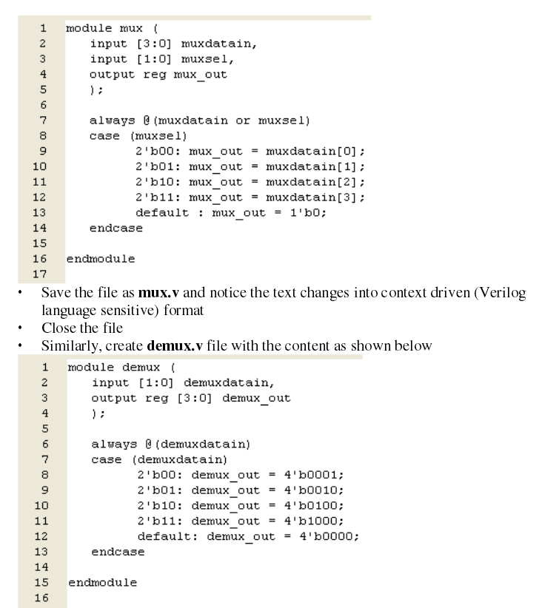

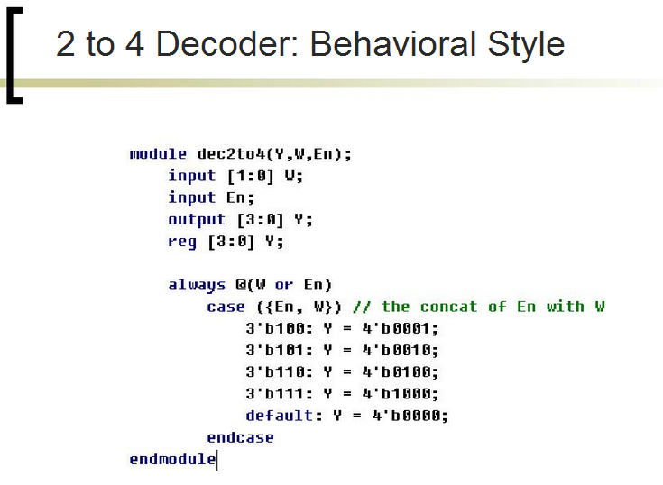

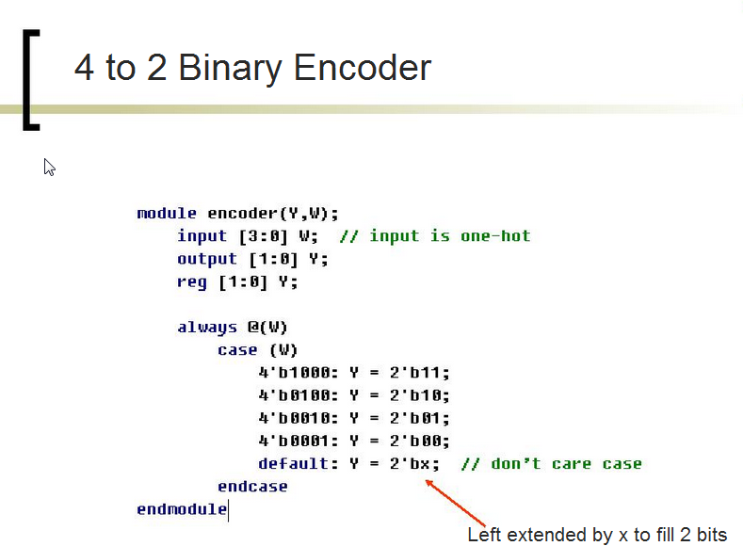

Registre à décalage utilize comme circuit de temporisation

